ANAMALY DETECTION AND RECOMMENDER SYSTEM

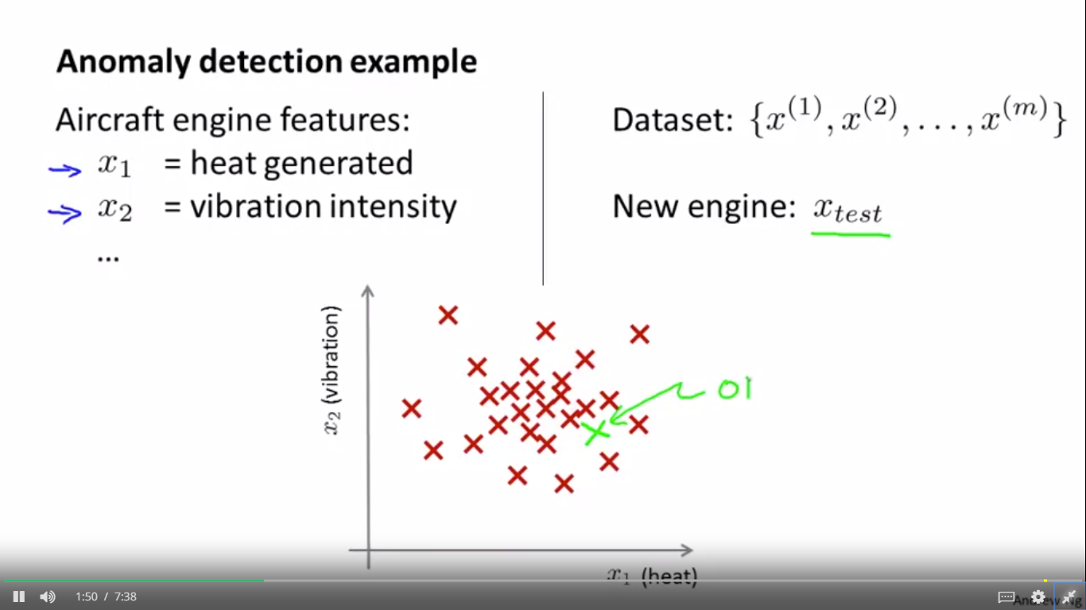

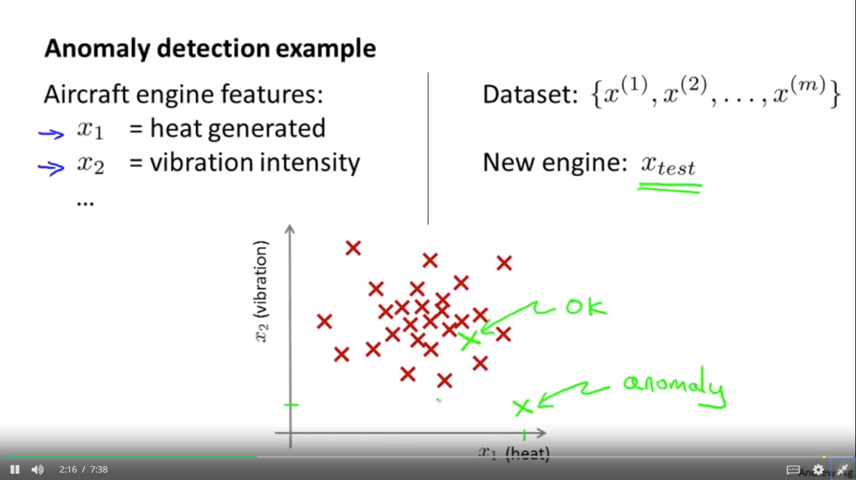 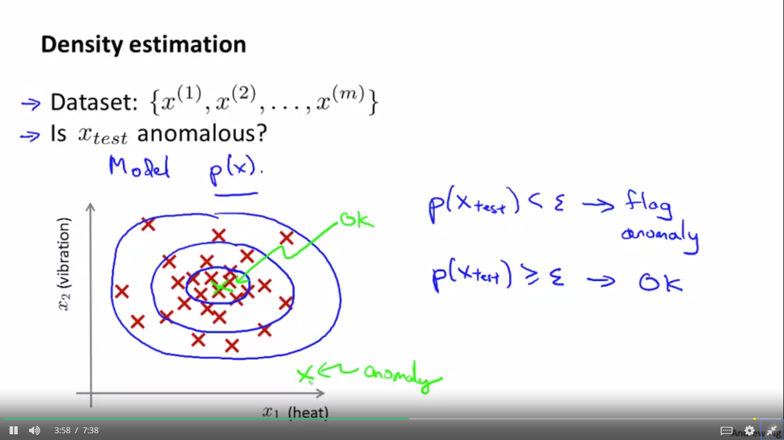

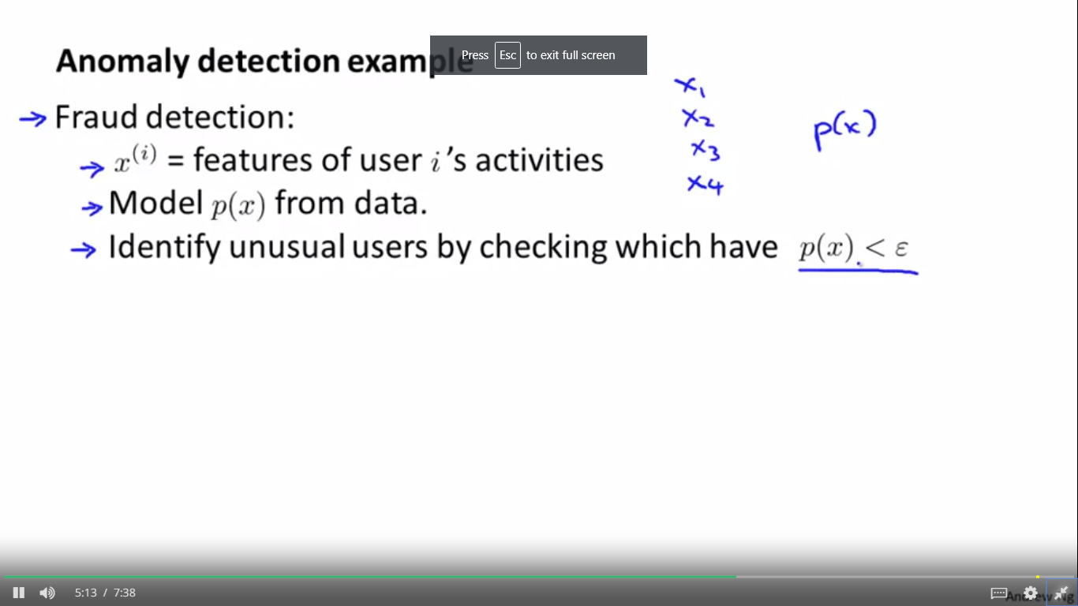

maybe x1 is how often does this user log in, x2, you know, maybe the number of what pages visited, or the number of transactions, maybe x3 is, you know, the number of posts of the users on the forum, feature x4 could be what is the typing speed of the user and some websites can actually track that was the typing speed of this user in characters per second. And so you can model p of x based on this sort of data.

5:08

And finally having your model p of x, you can try to identify users that are behaving very strangely on your website by checking which ones have probably effects less than epsilon and maybe send the profiles of those users for further review.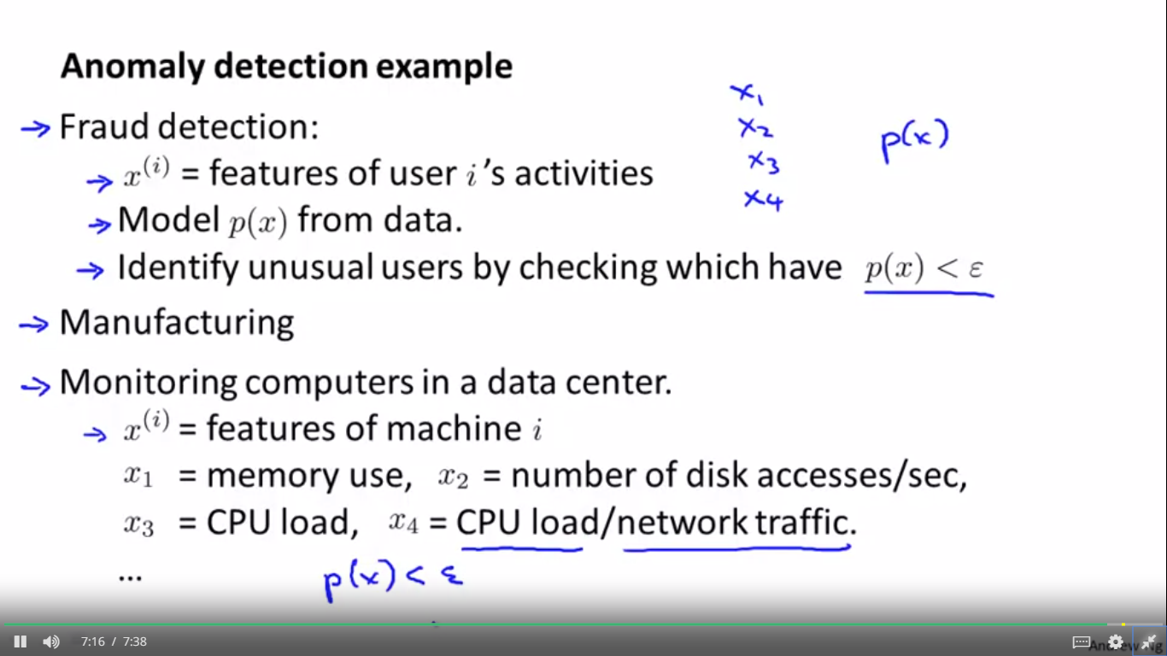 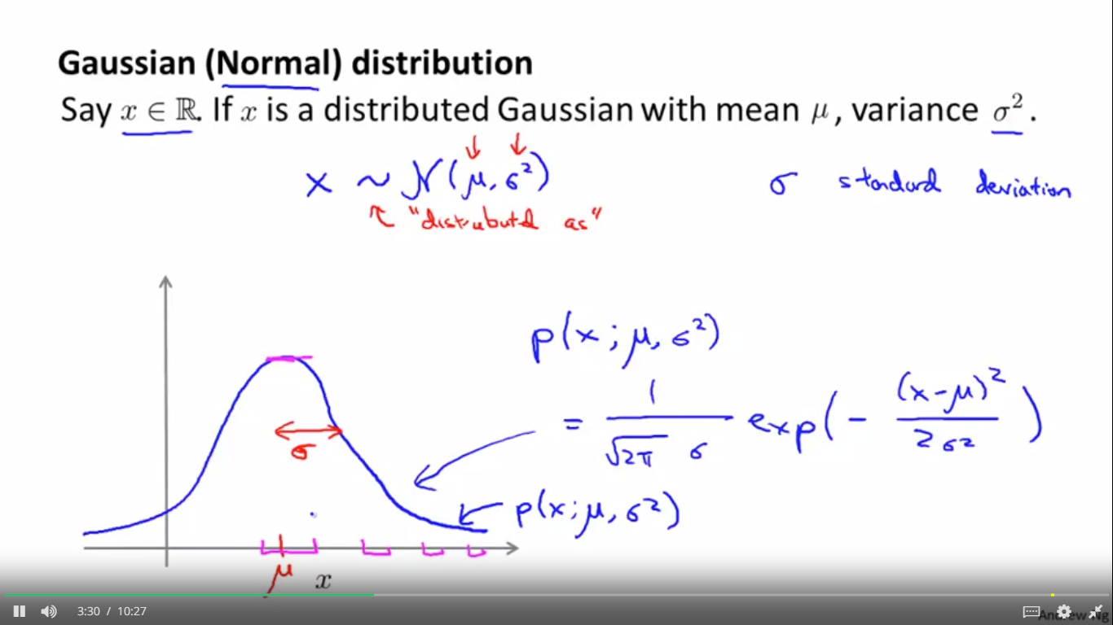 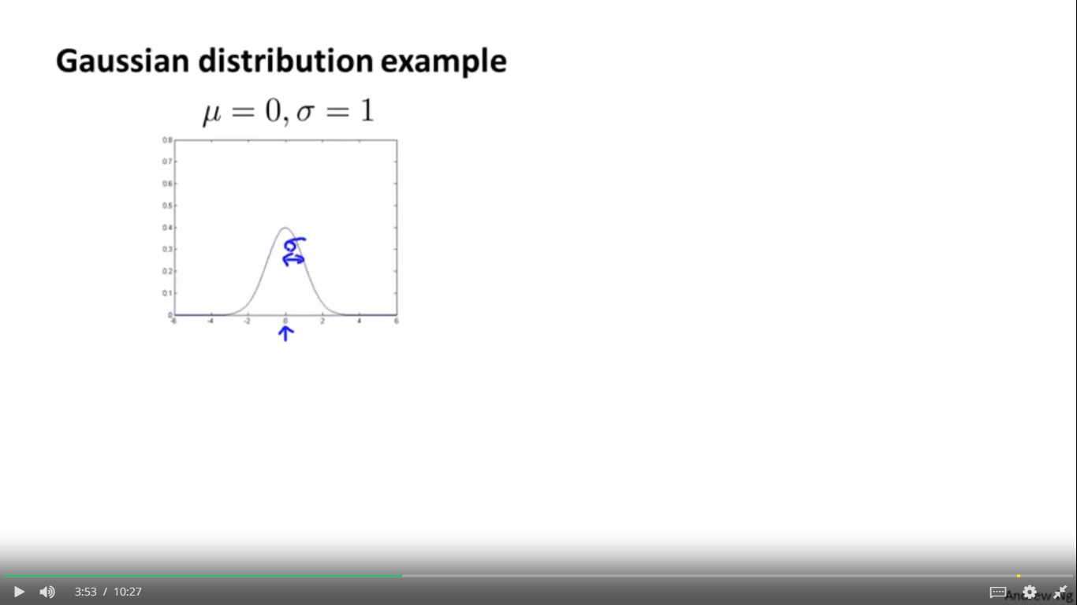 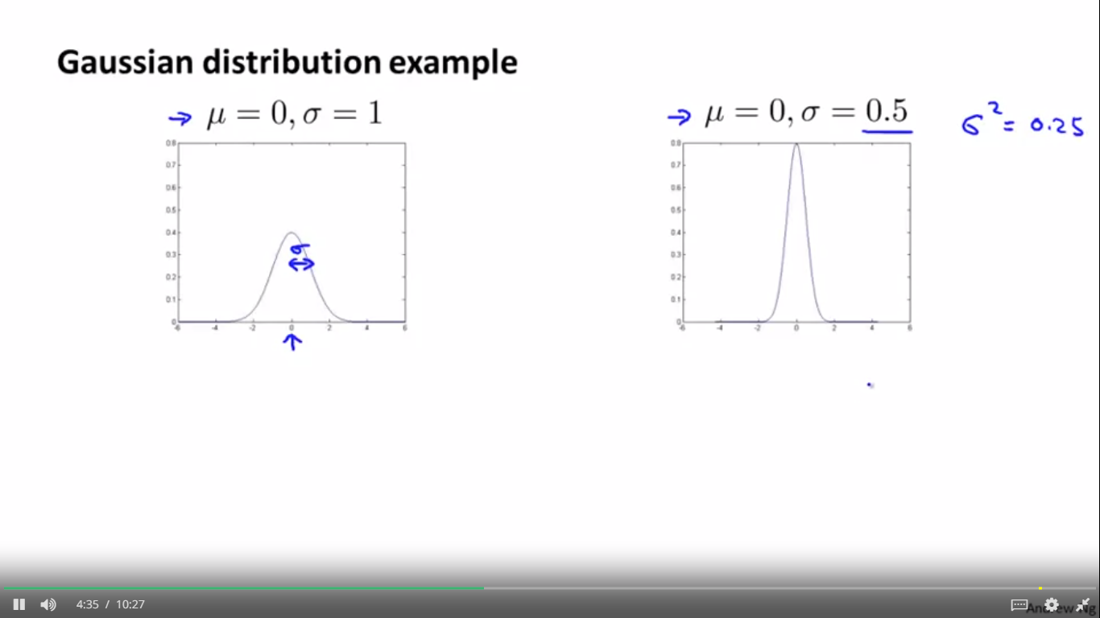

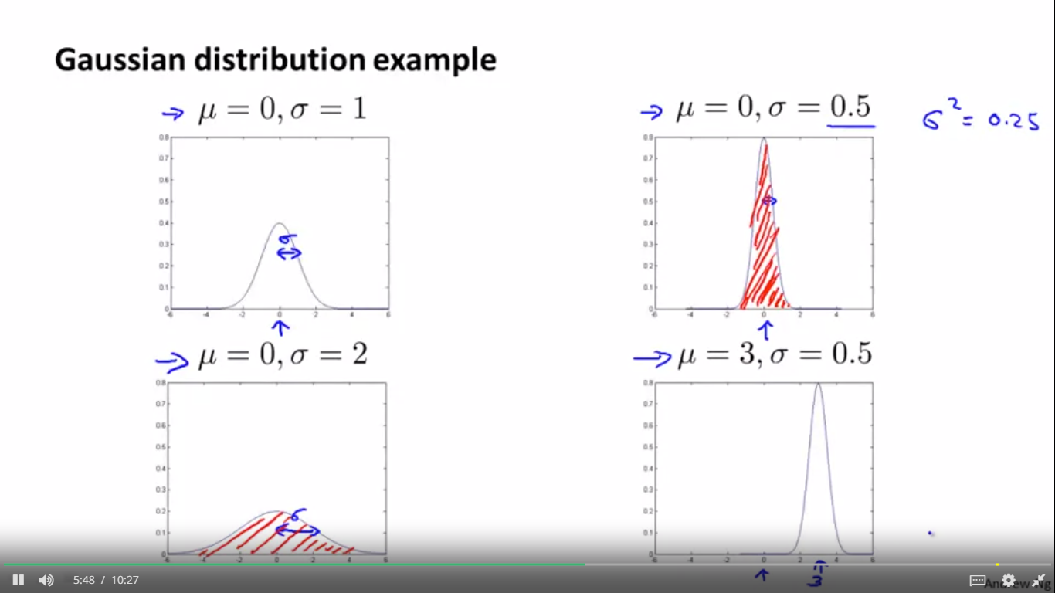 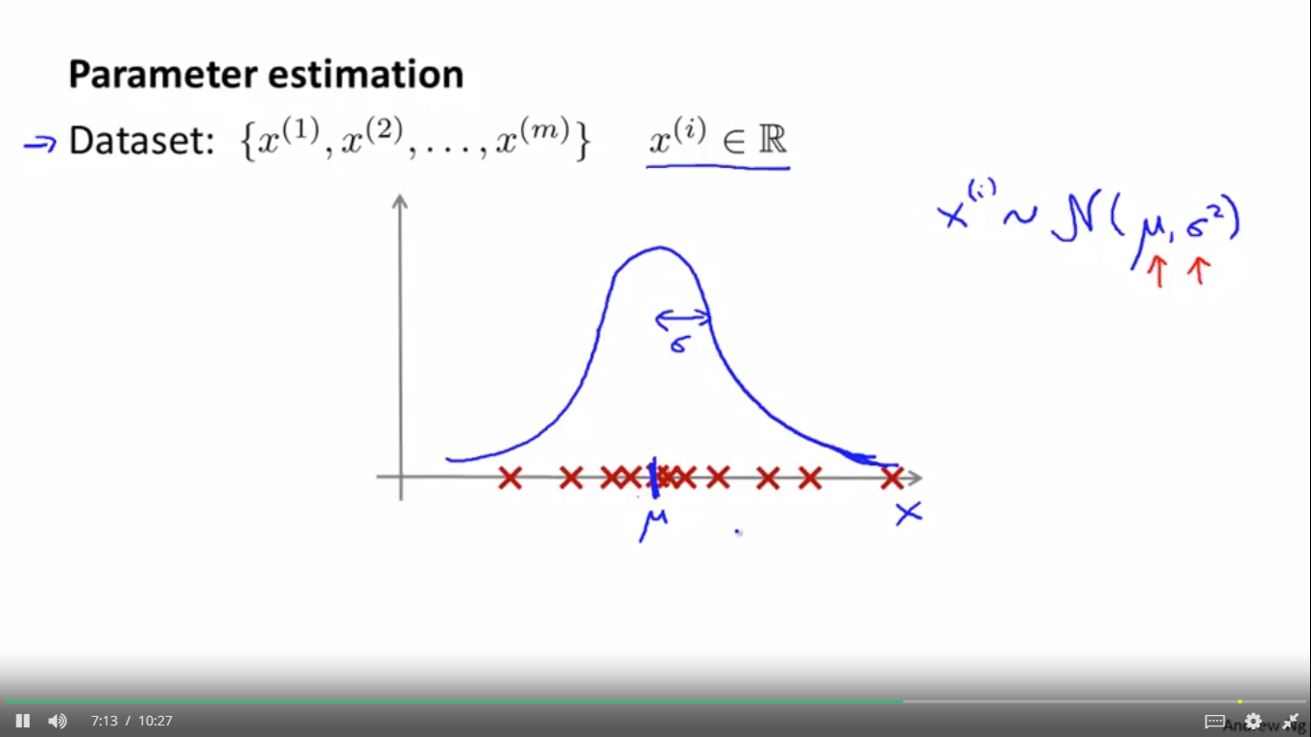

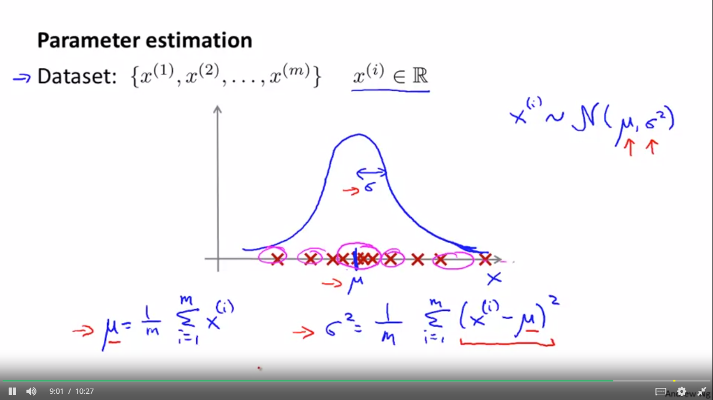

ALGORITHM

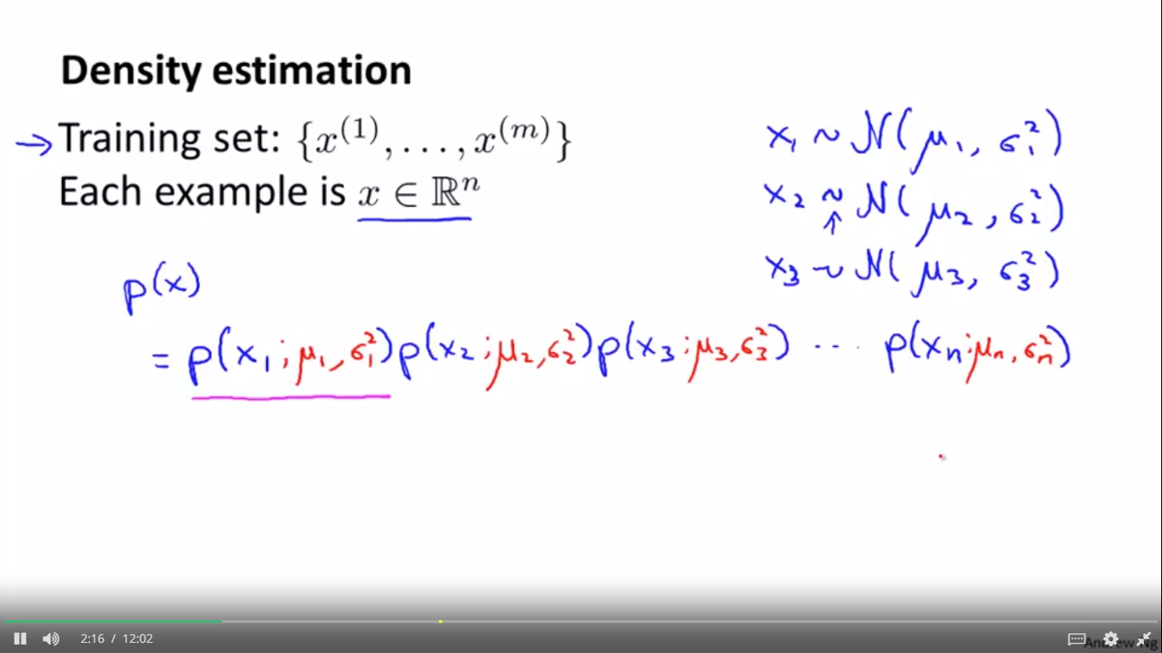

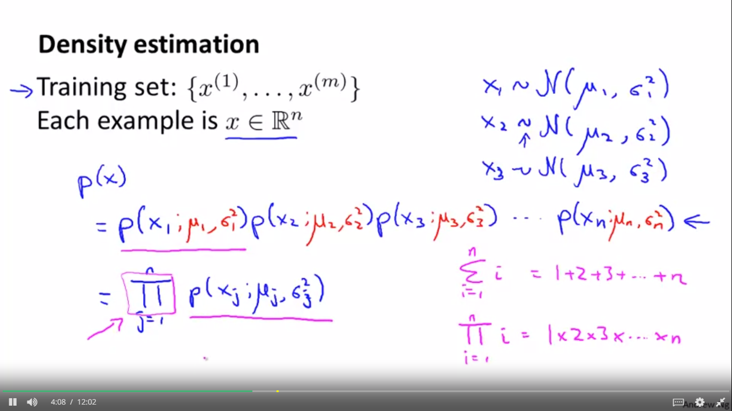 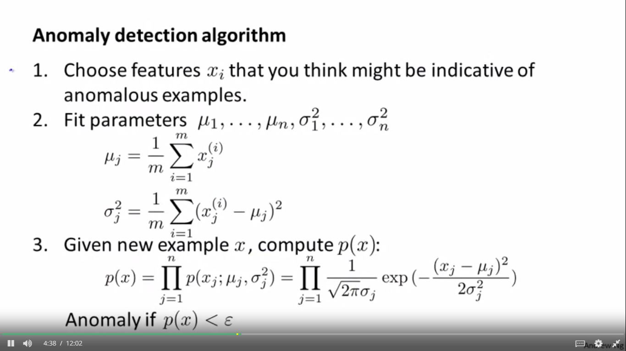 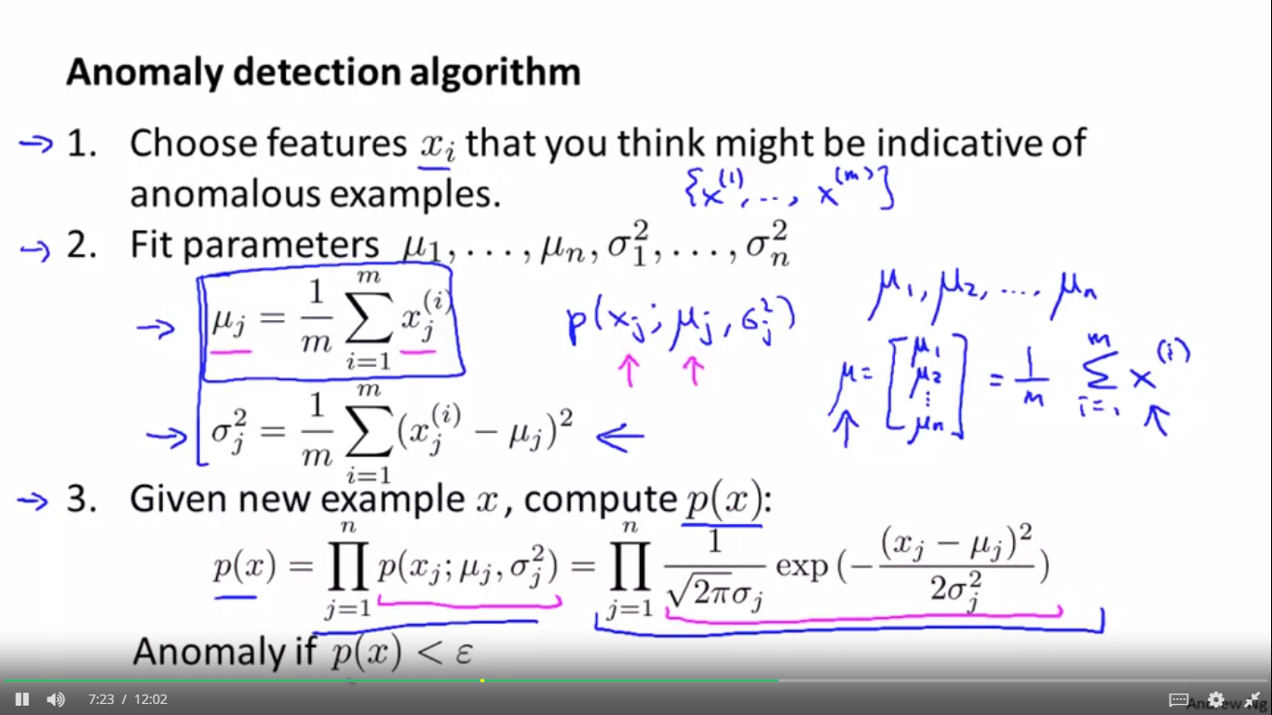

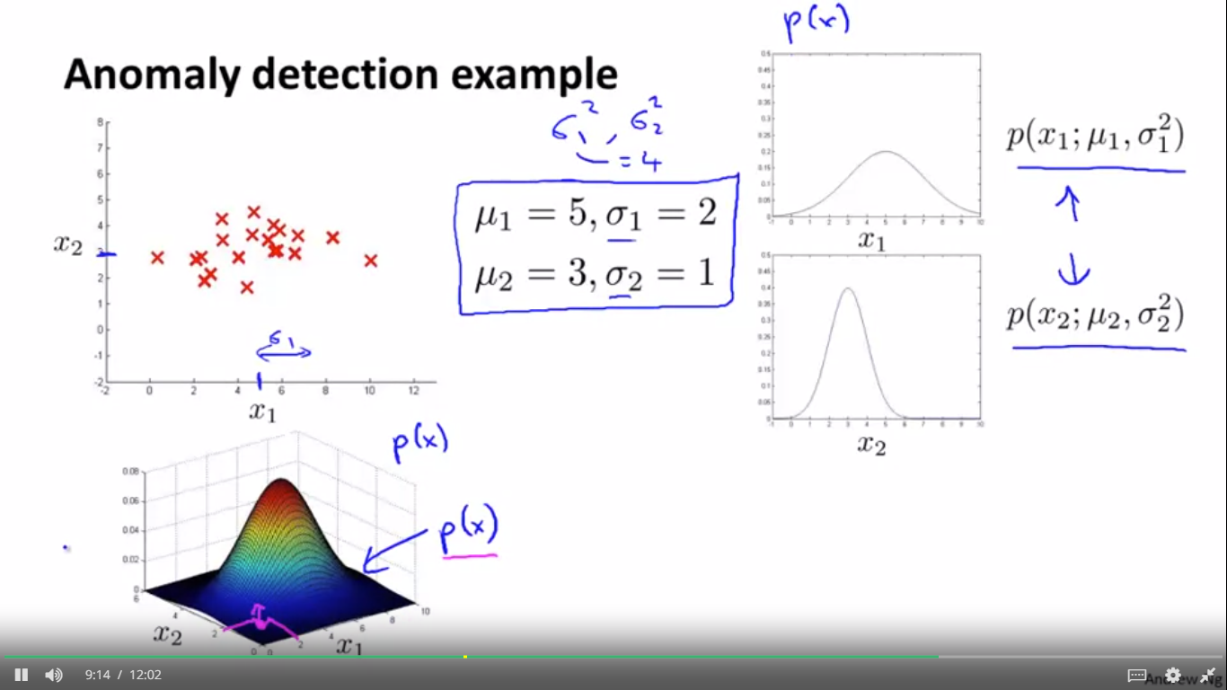

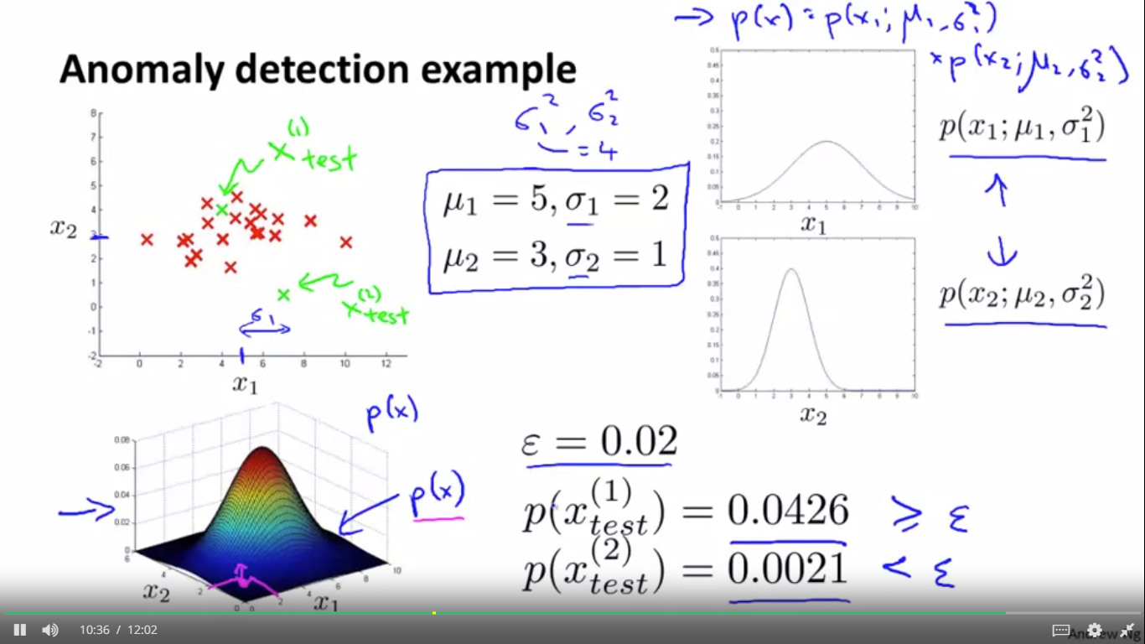

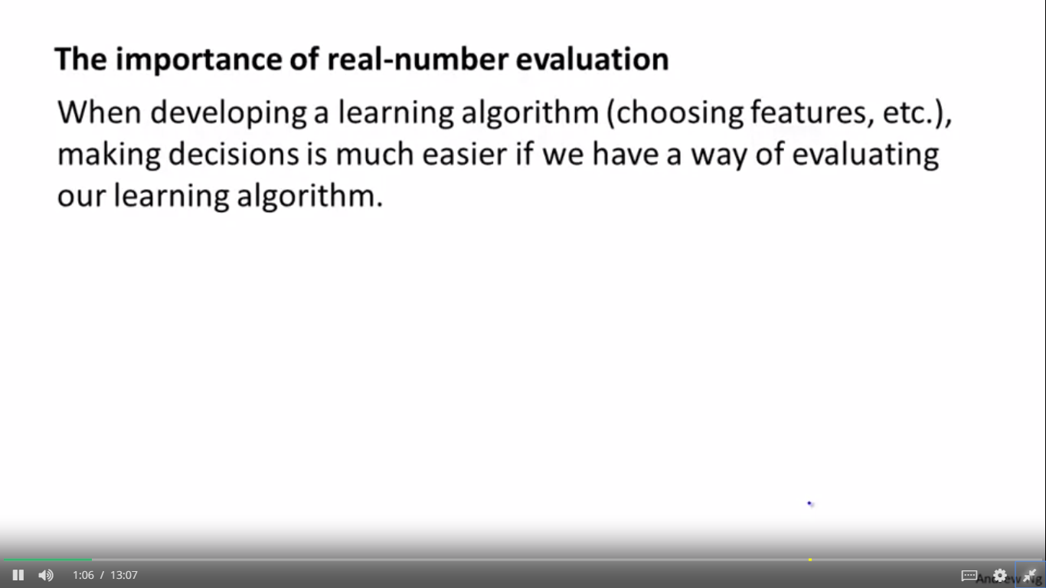 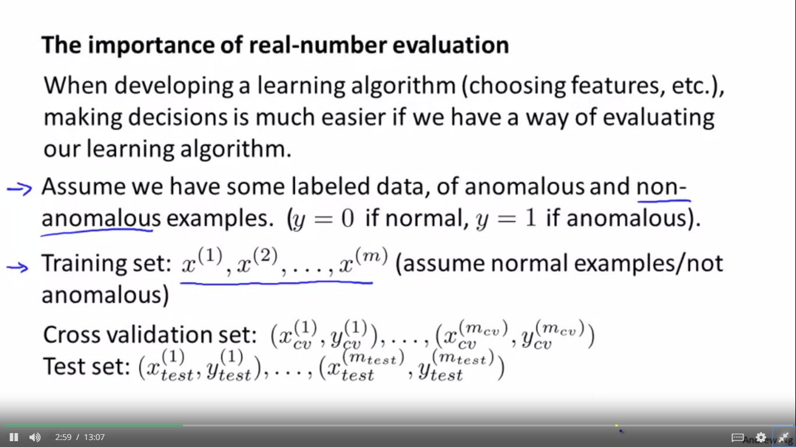 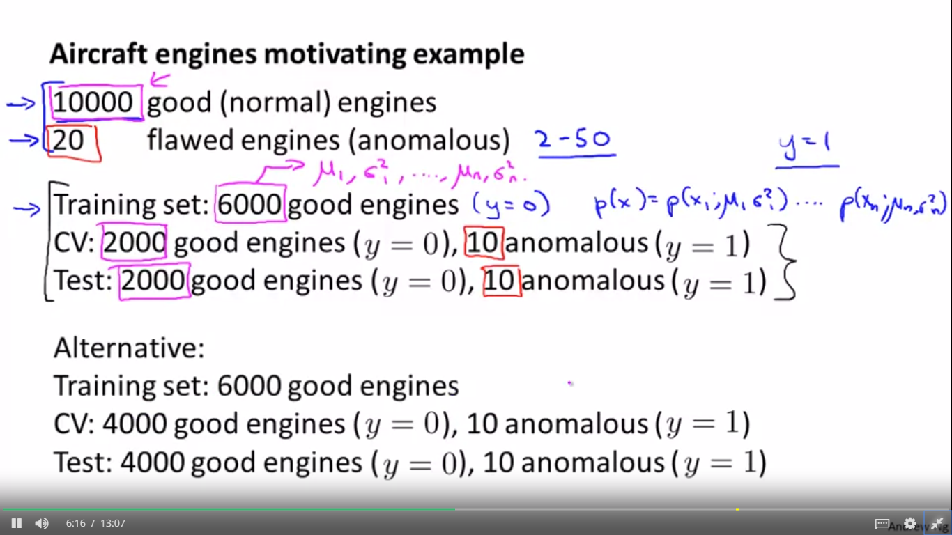 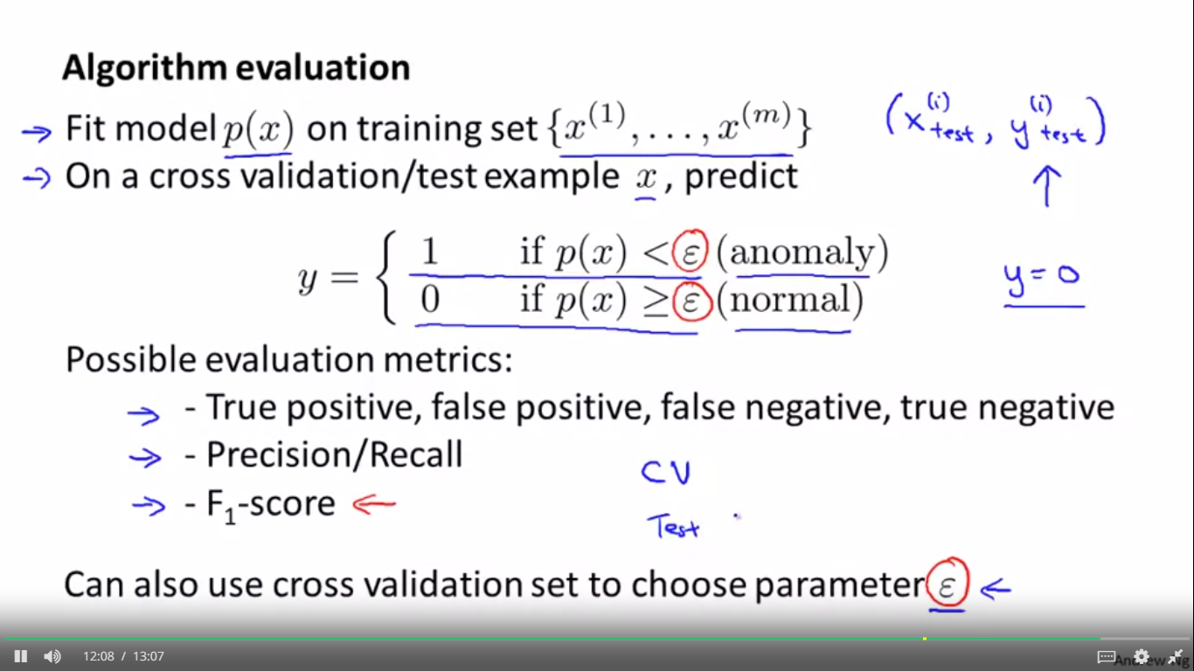 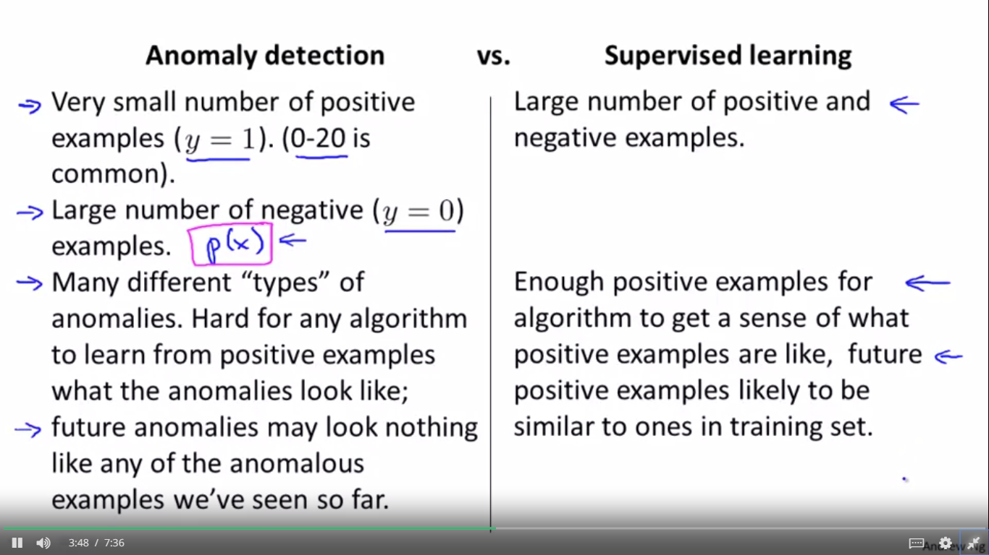 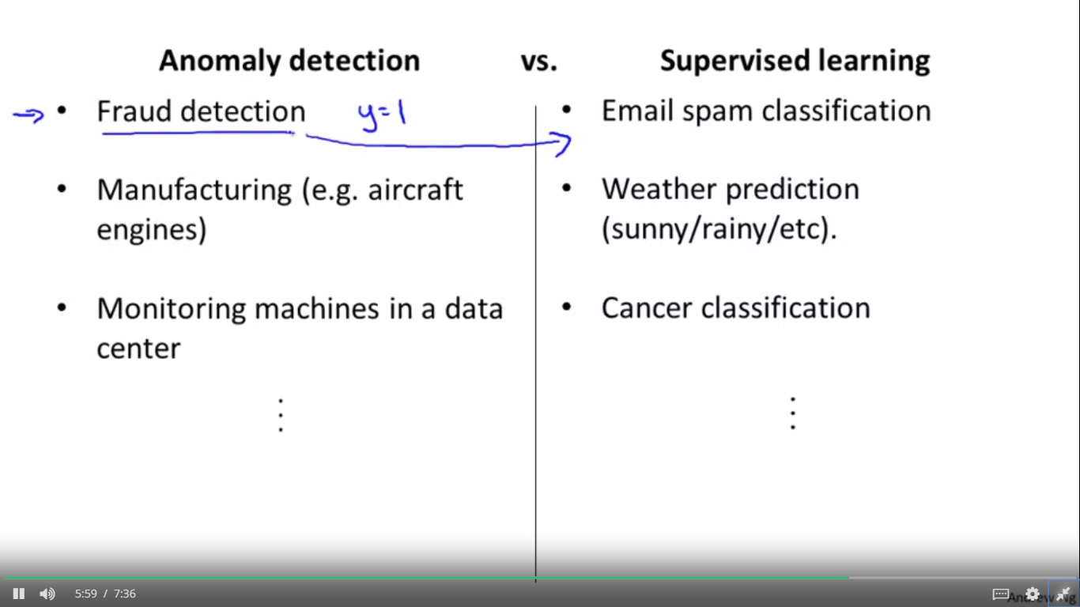 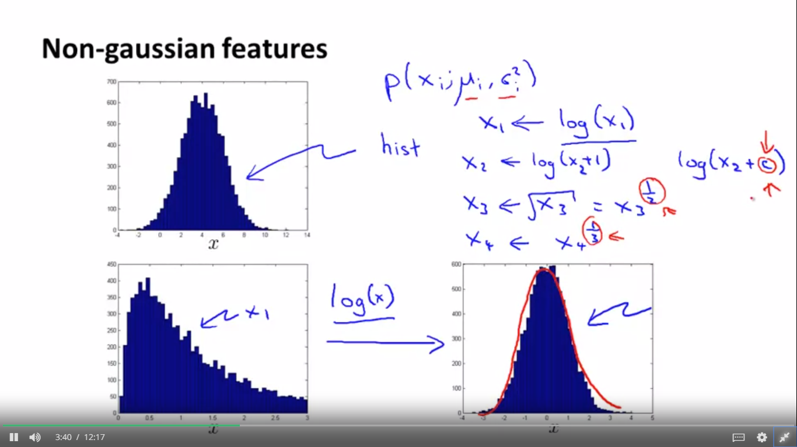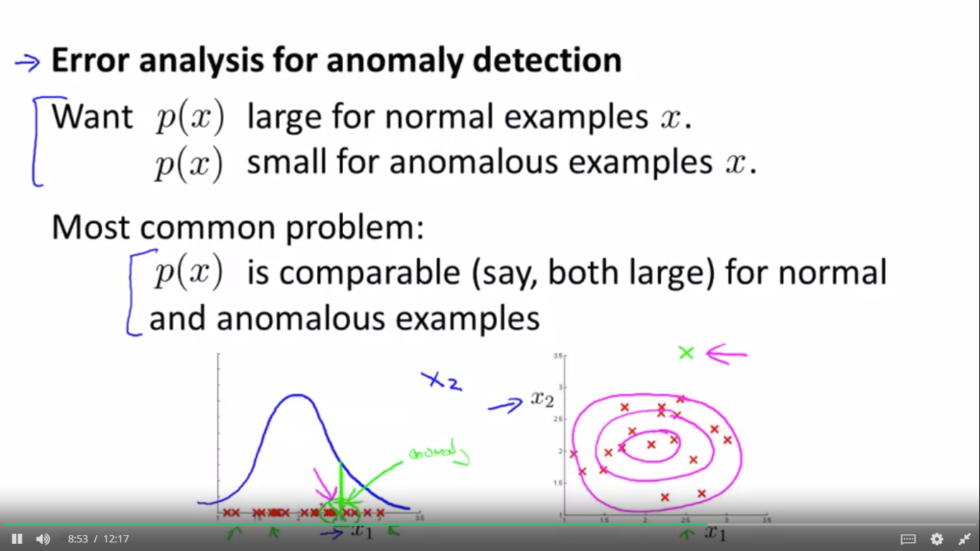

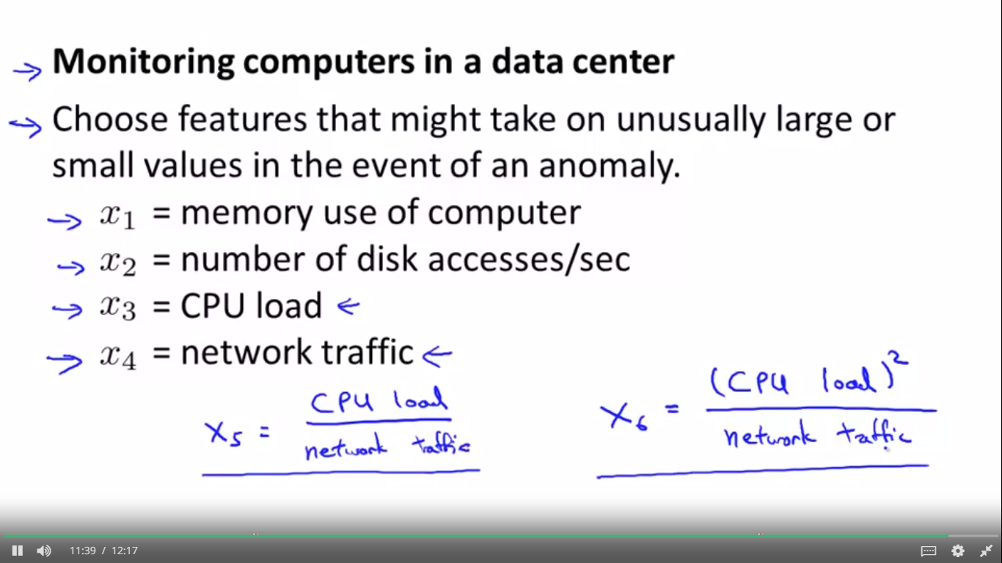

But let's say, I think,

let's say I have a suspicion, that one of the failure cases is if one of my computers has a job that gets stuck in some infinite loop. So if I think one of the failure cases, is one of

my machines, one of my web servers--server code-- gets stuck in some infinite loop, and so the CPU load grows, but the network traffic doesn't because it's just spinning it's wheels and doing a lot of CPU work, you know, stuck in some infinite loop. In that case, to detect that type of anomaly, I might create a new feature, X5, which might be CPU load10:56

divided by network traffic.11:01And so here X5 will take on a unusually large value

if one of the machines has a very large CPU load but not that much network traffic and

so this will be a feature that will help your anomaly detection capture, a certain type of anomaly.

And you can also get creative and come up with other features as well. Like maybe I have a feature x6 thats CPU load squared divided by network traffic.

11:27

And this would be another variant of a feature like x5 to try to capture anomalies where one

of your machines has a very high CPU load, that maybe doesn't have a commensurately large network traffic.

MULTIVARIANT GAUSSIAN DISTRIBUTION

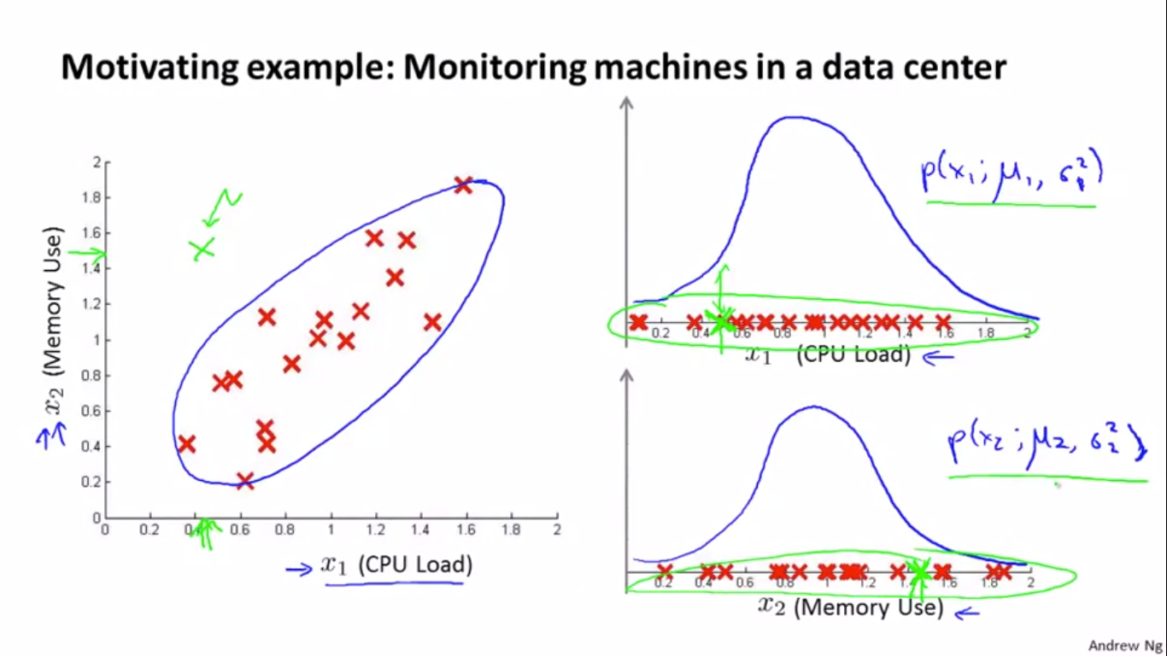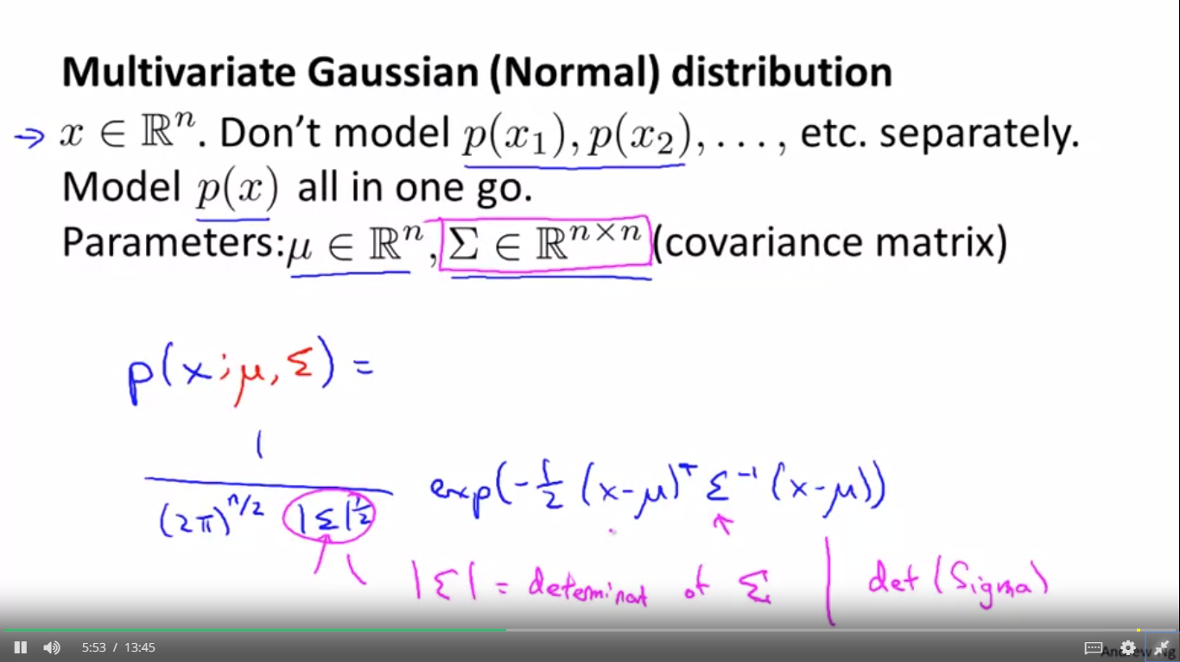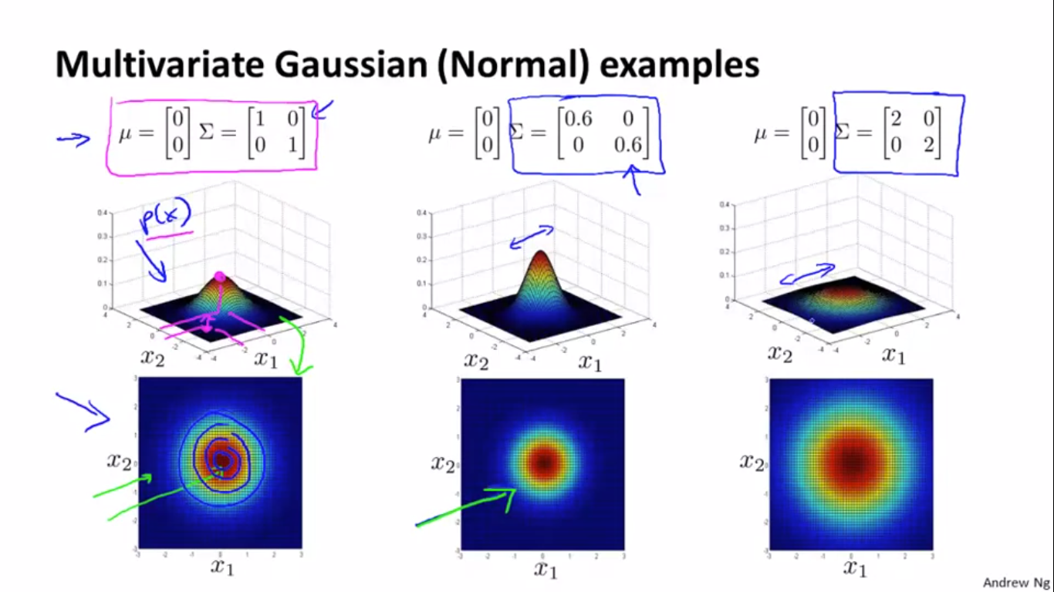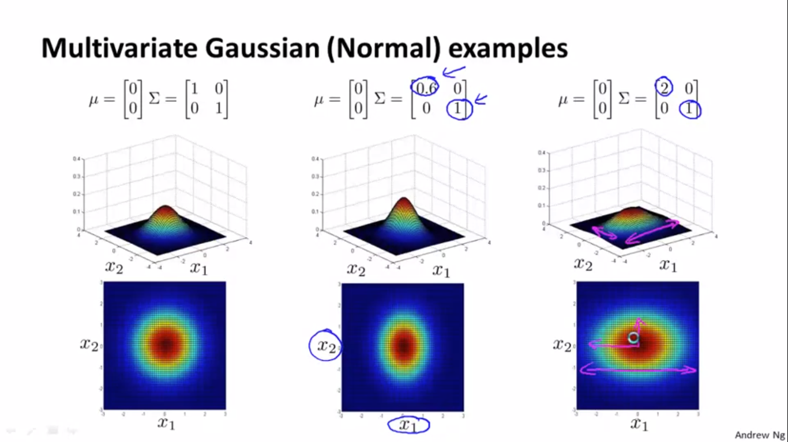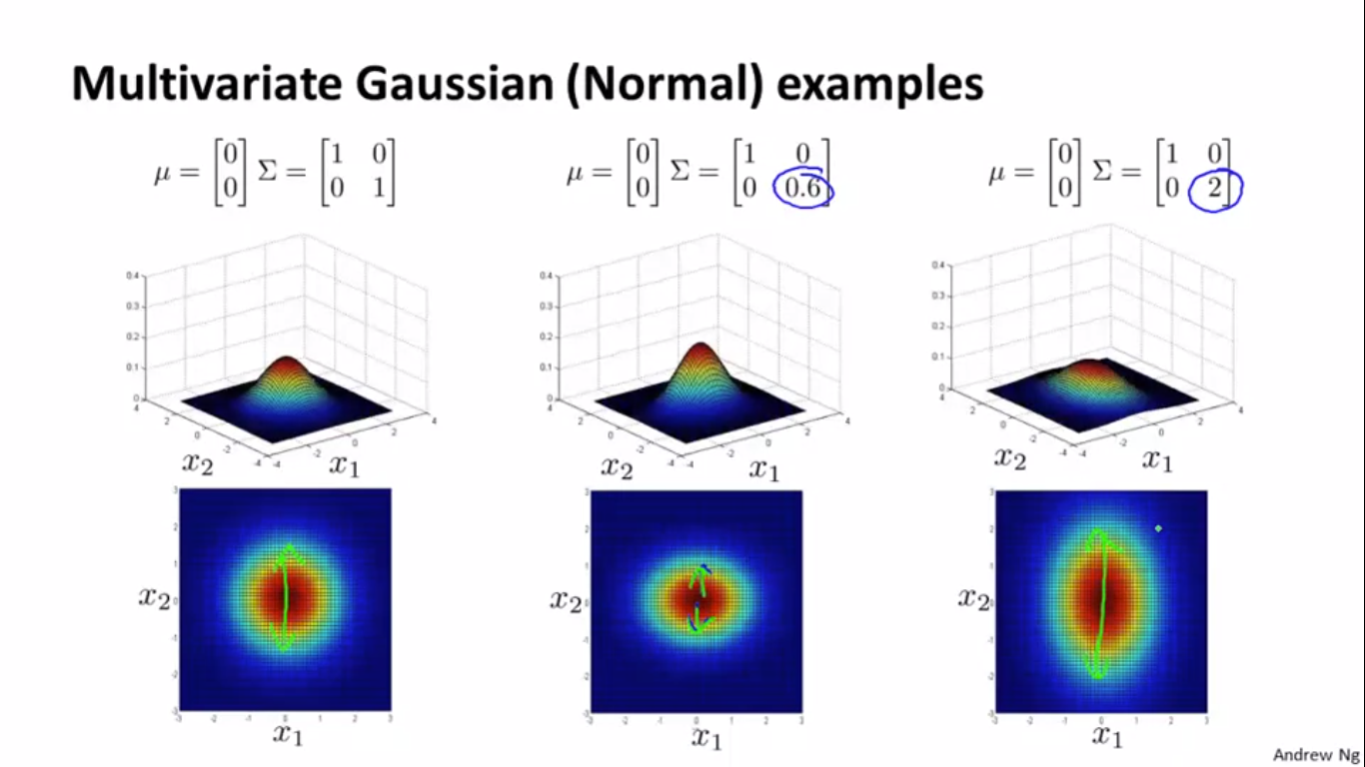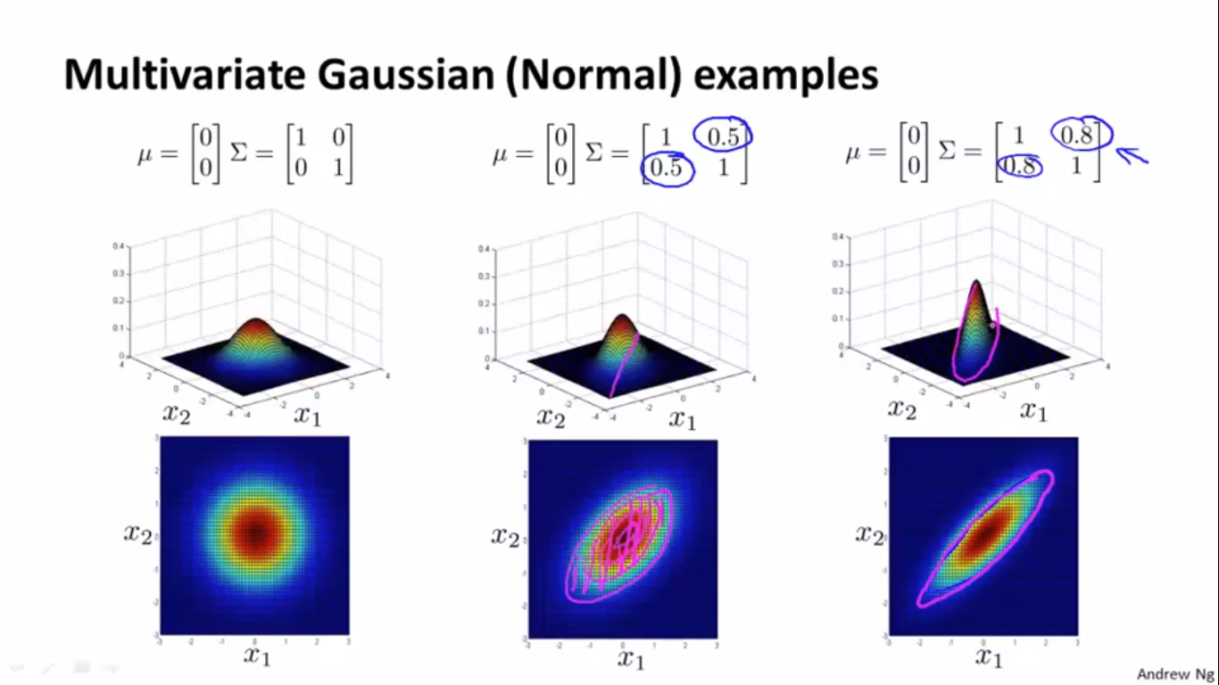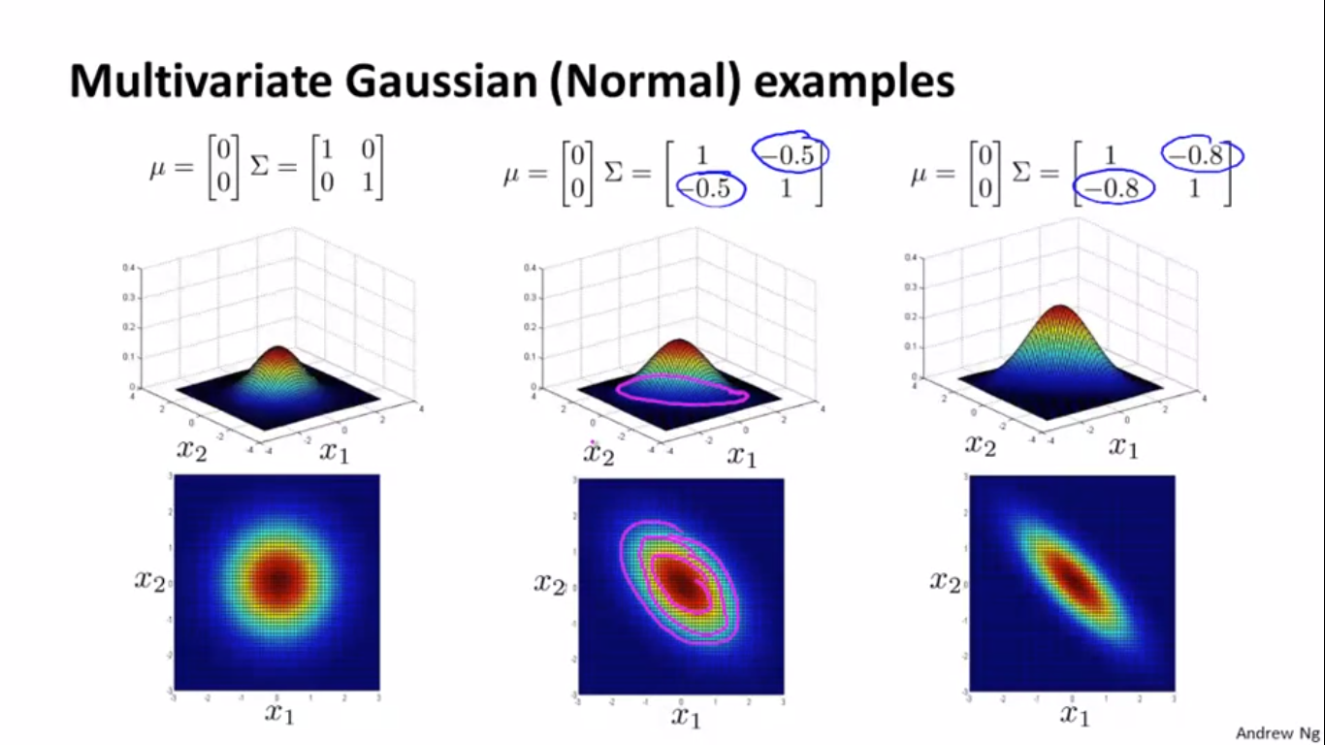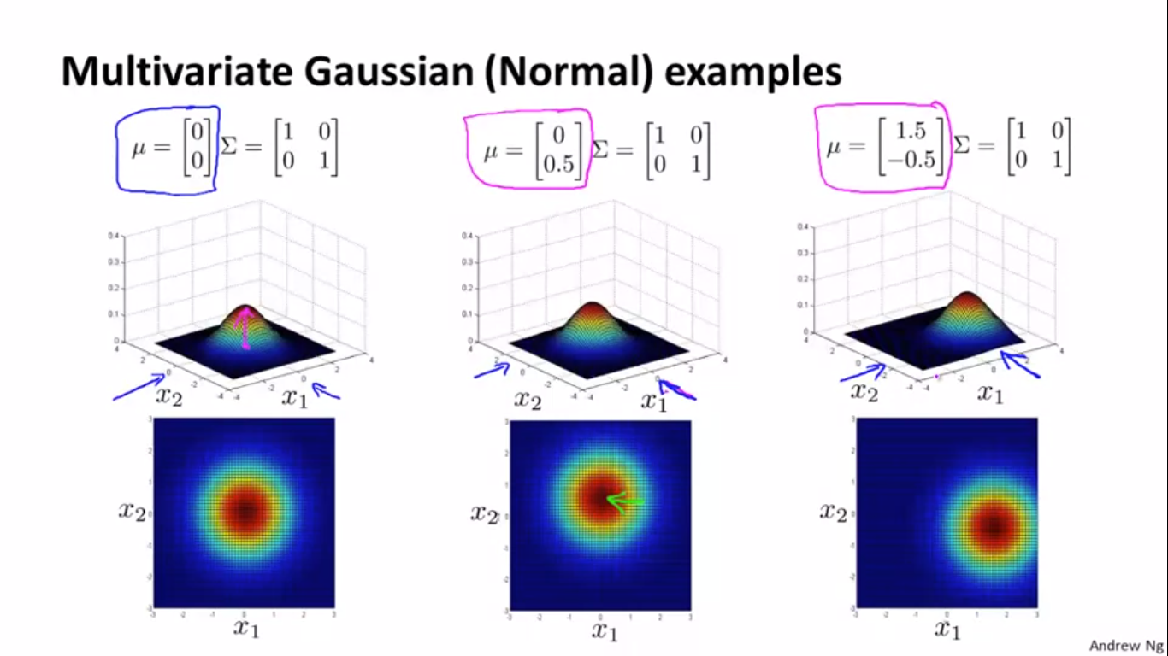

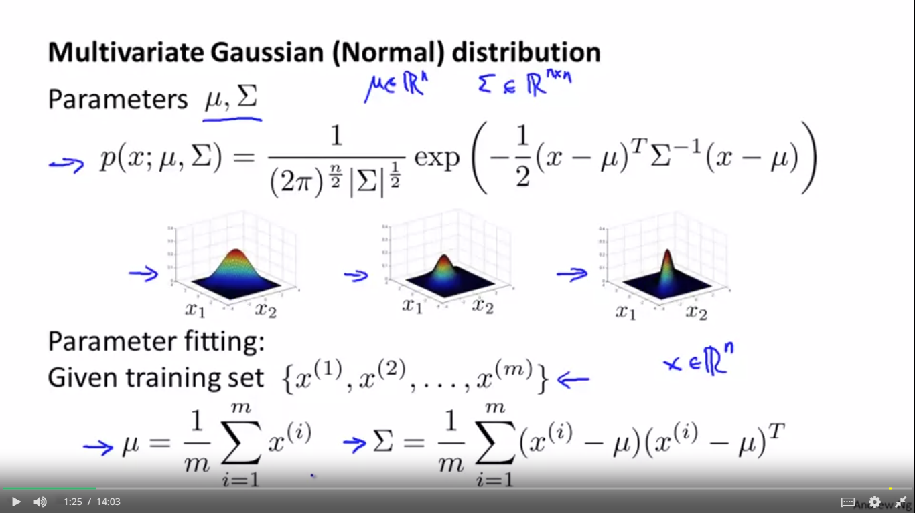

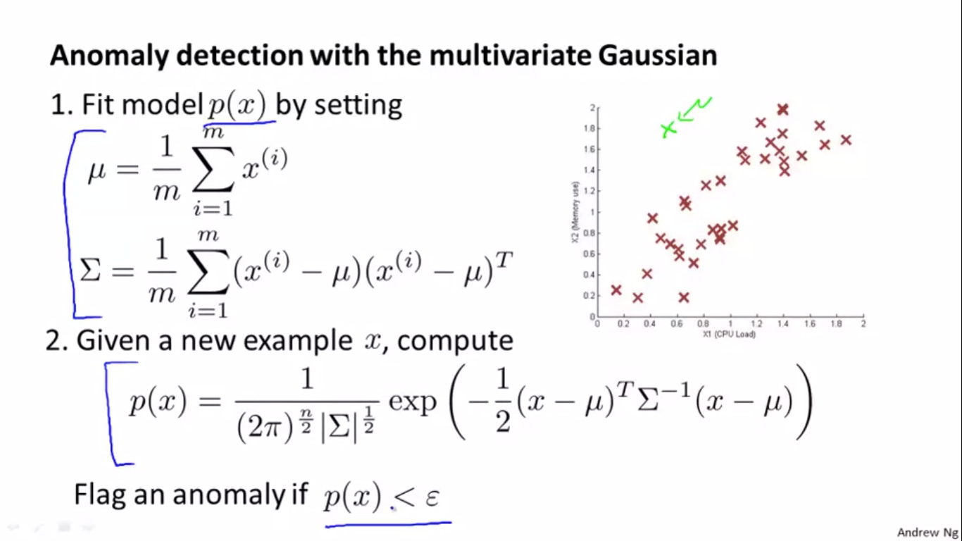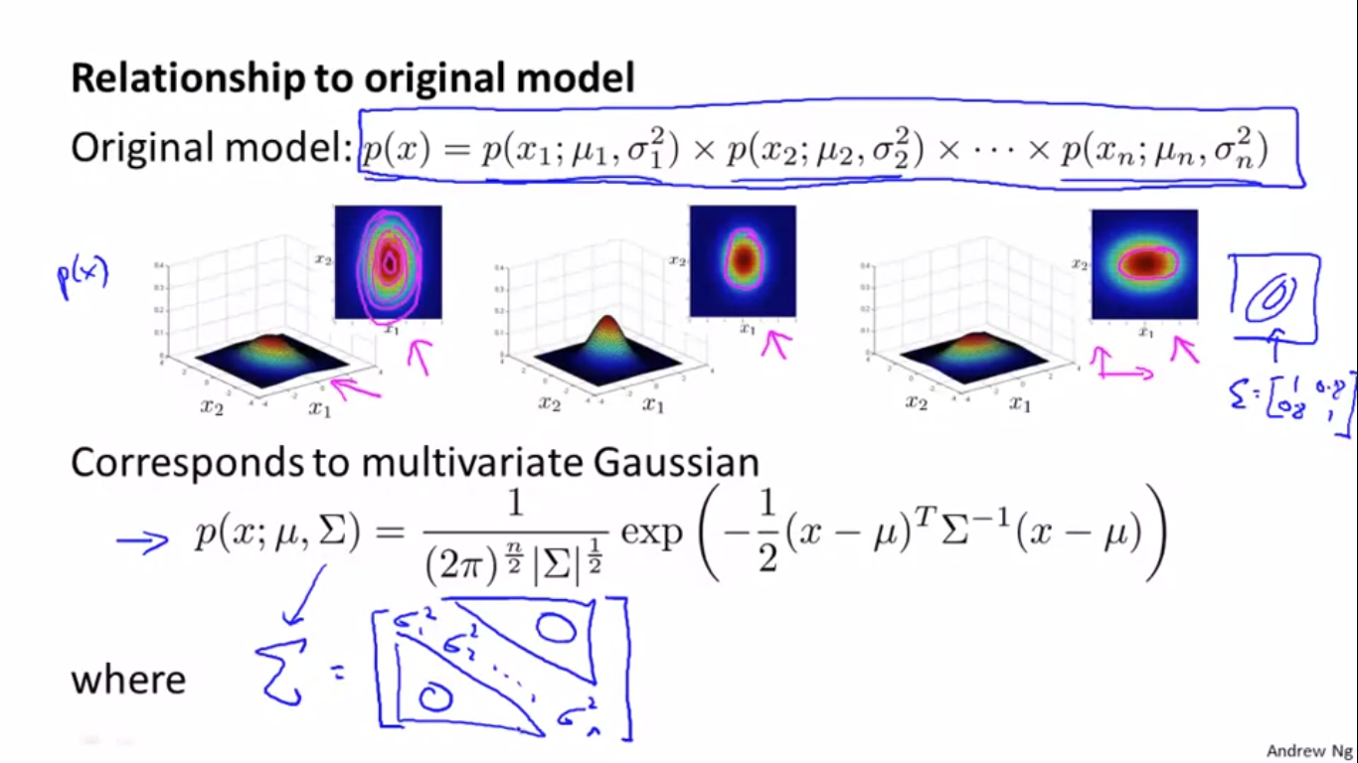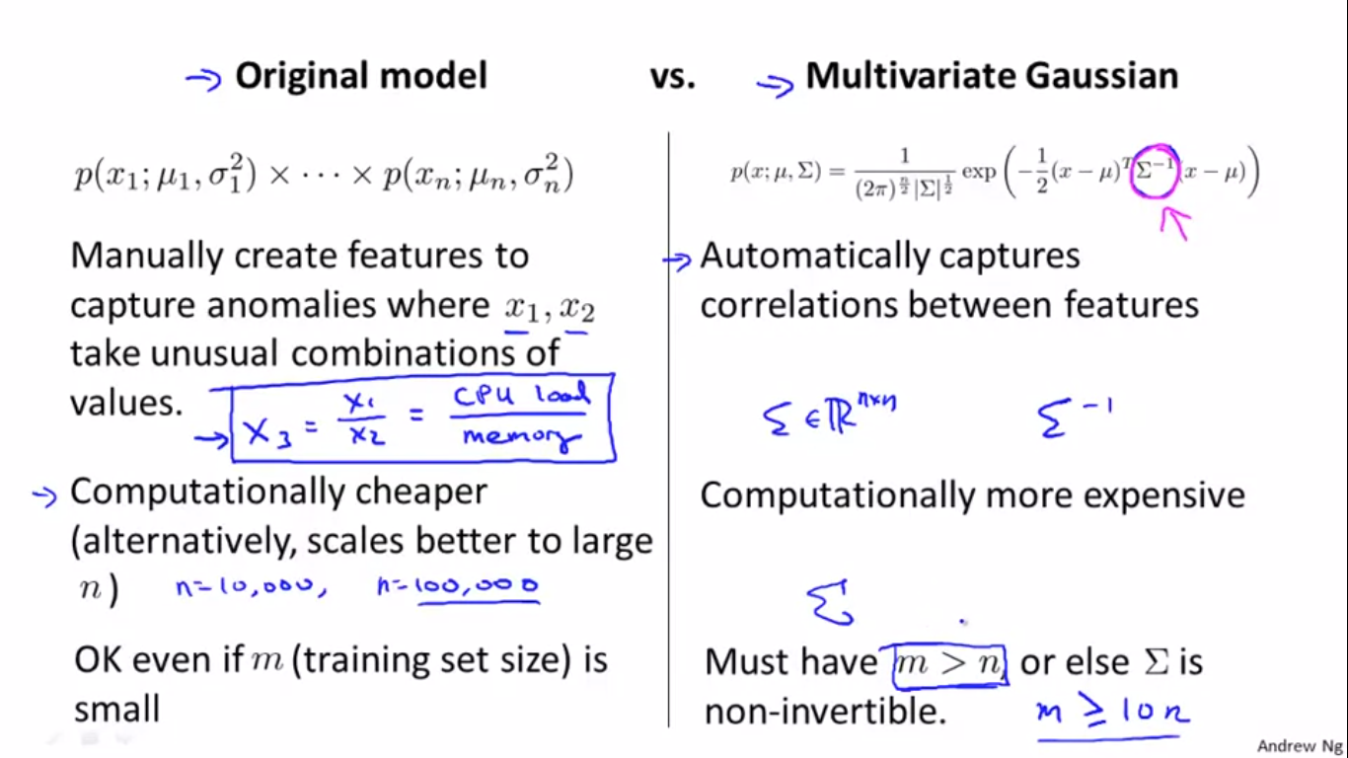

RECOMMENDER SYSTEM – CONTENT BASED ALGORITHM

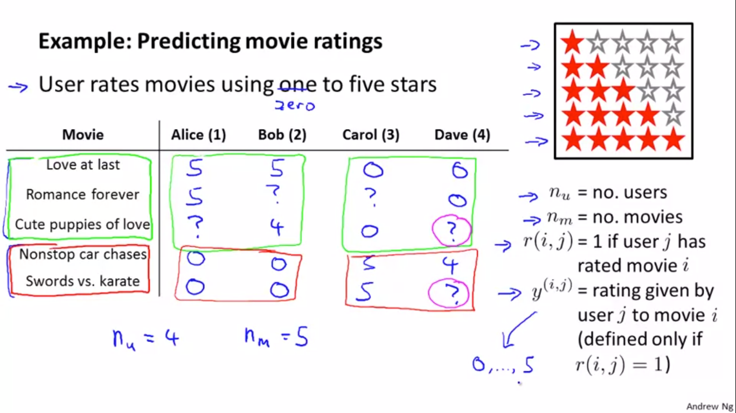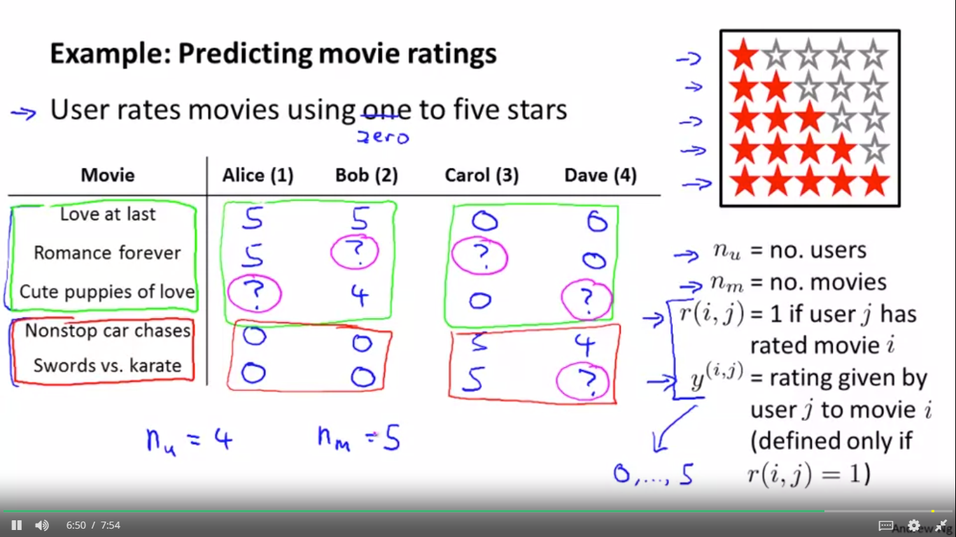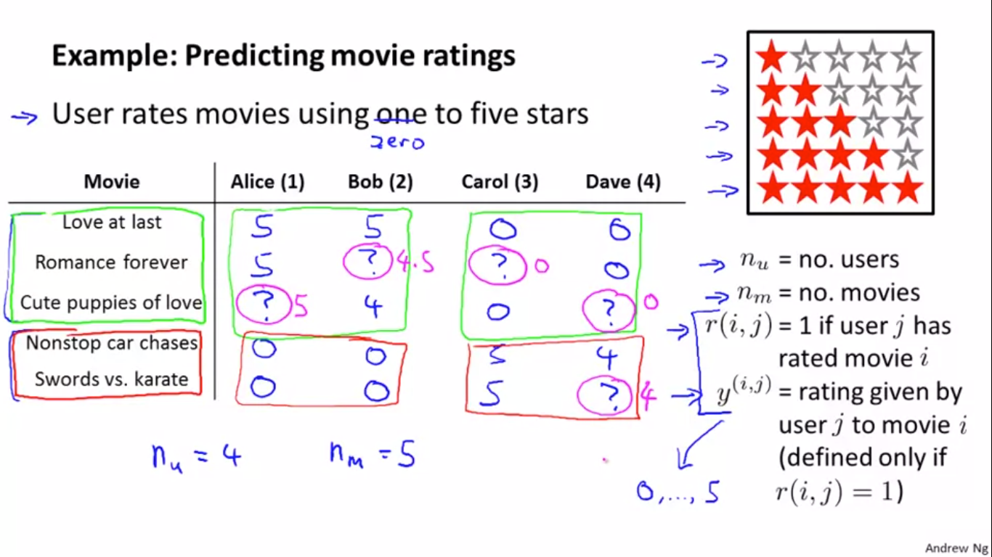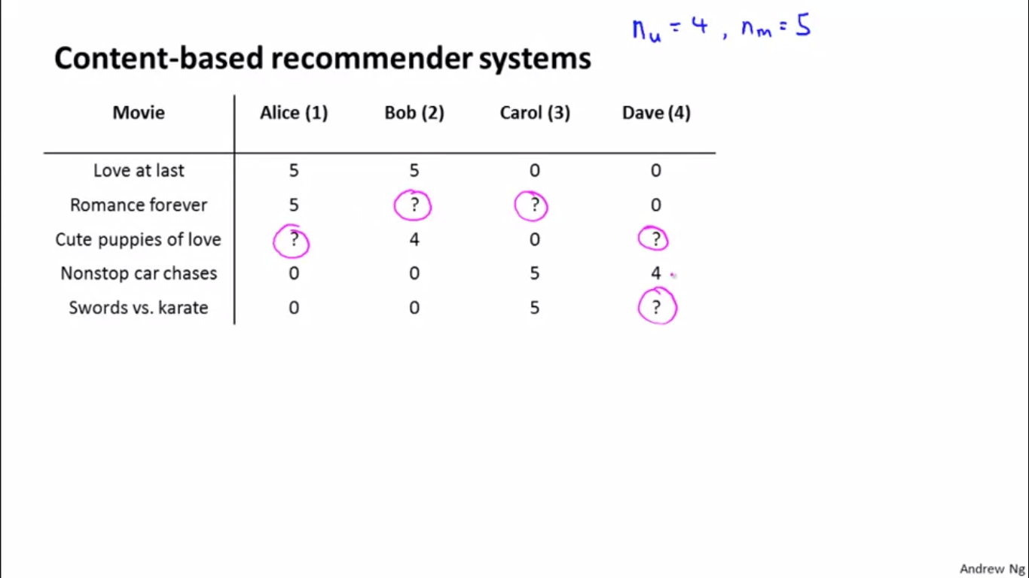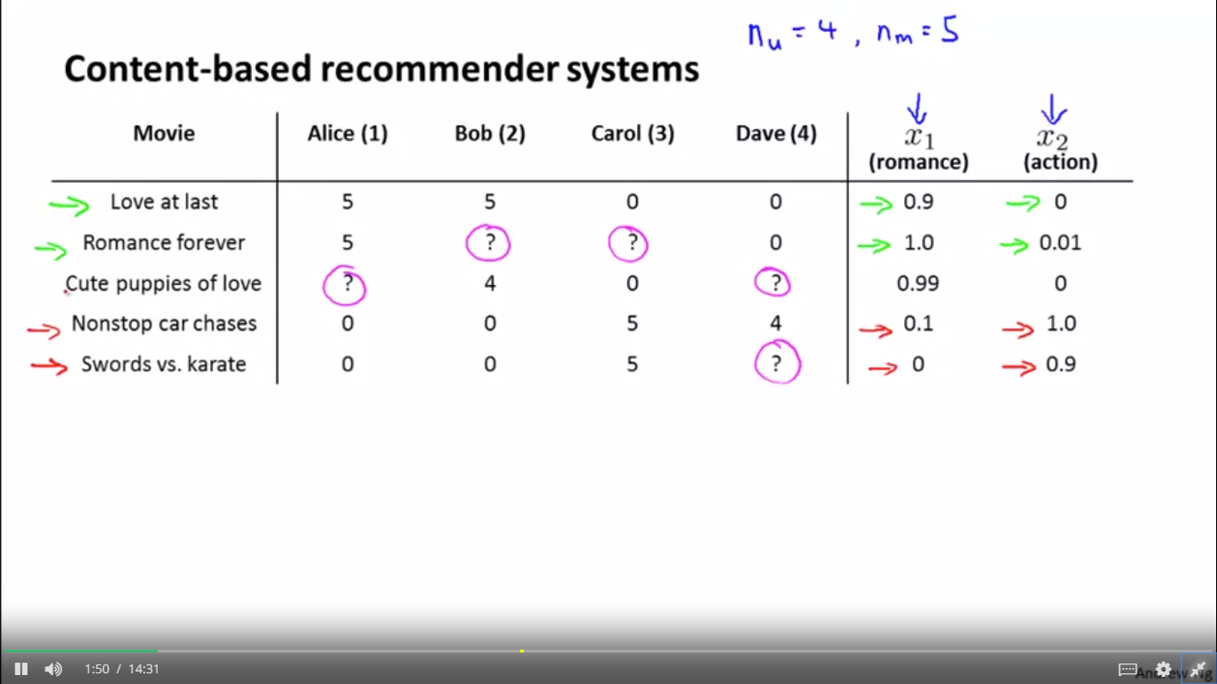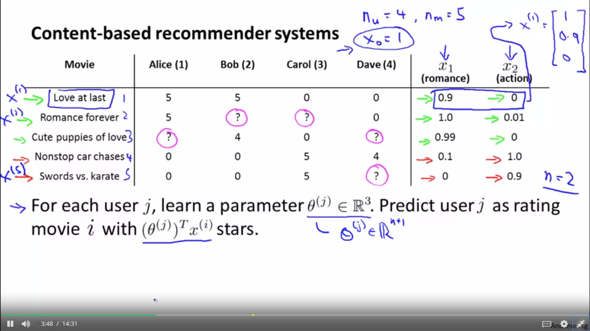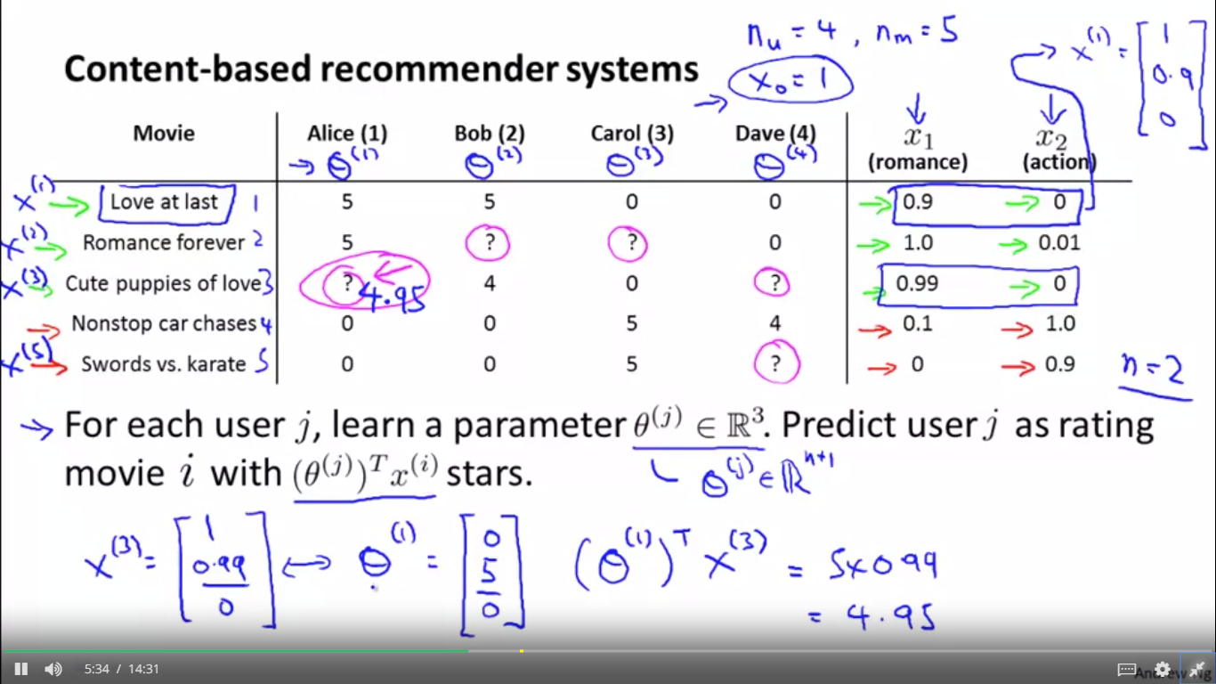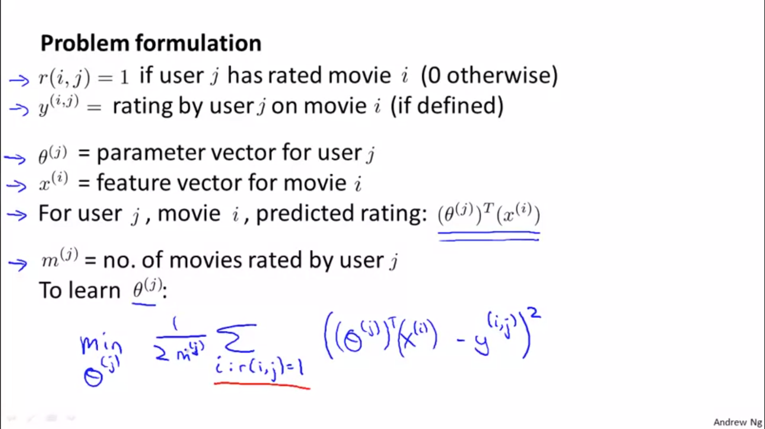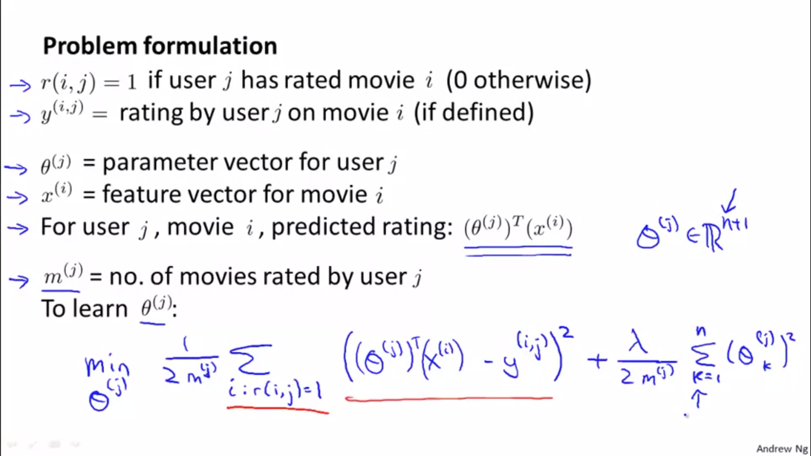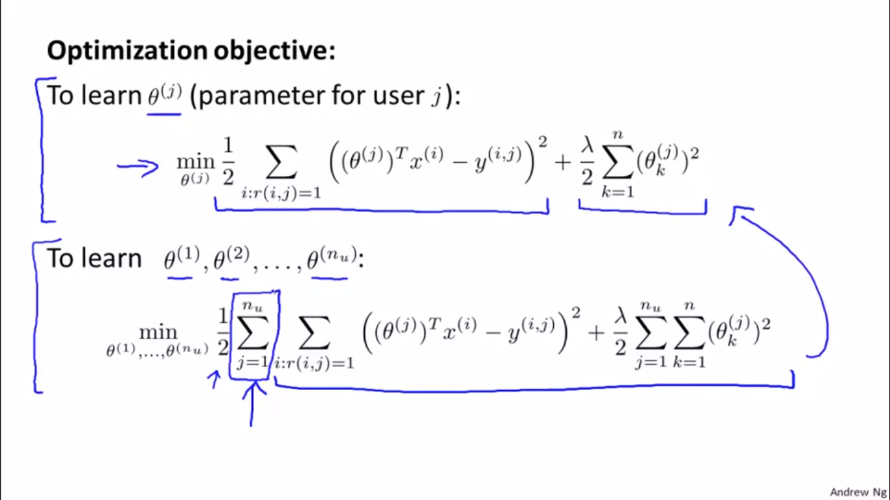

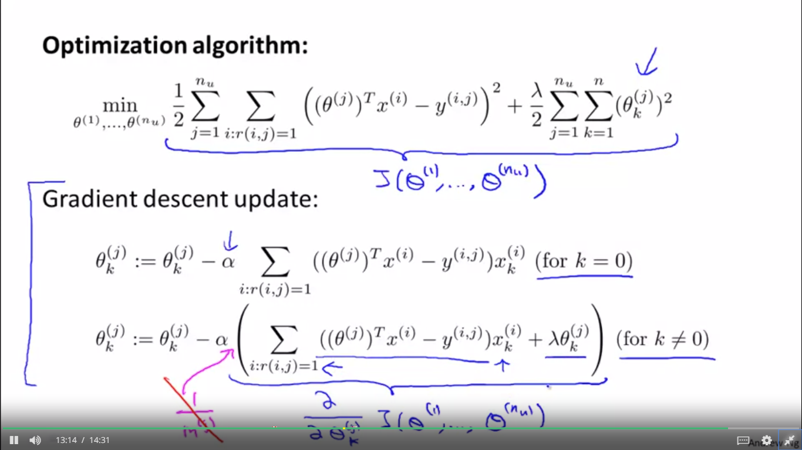

RECOMMENDER SYSTEM – Collaborative filtering ALGORITHM

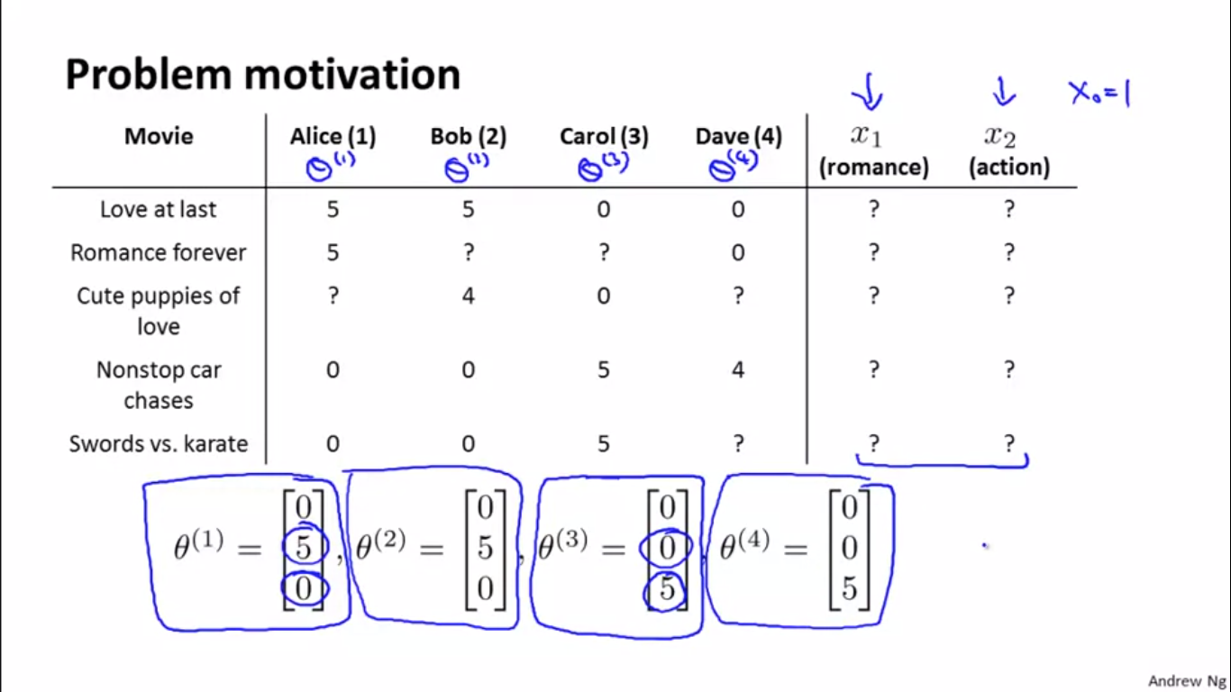

X0 equals 1 and let's say that Carol tells us she doesn't like romantic movies and so on, similarly for Dave. So let's assume that somehow we can go to users and each user J just tells us what is the value of theta J for them. And so basically specifies to us of how much they like different types of movies.

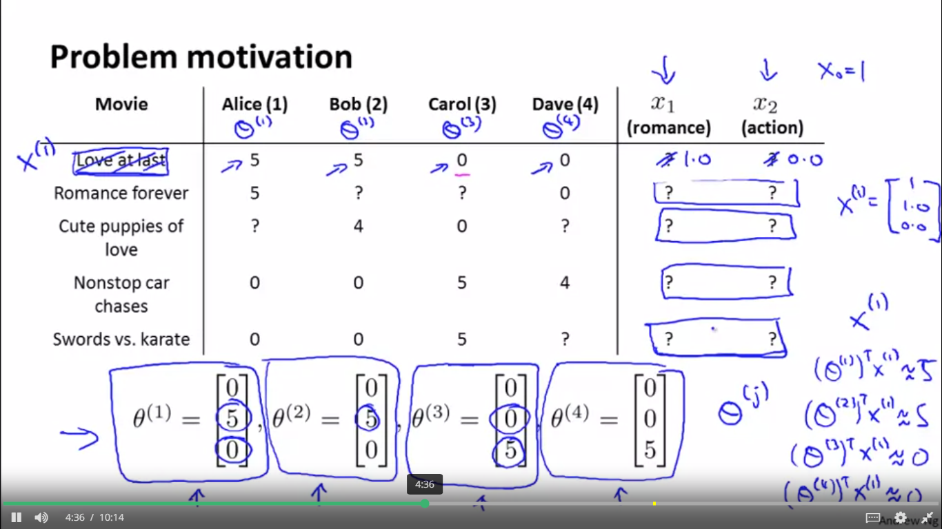 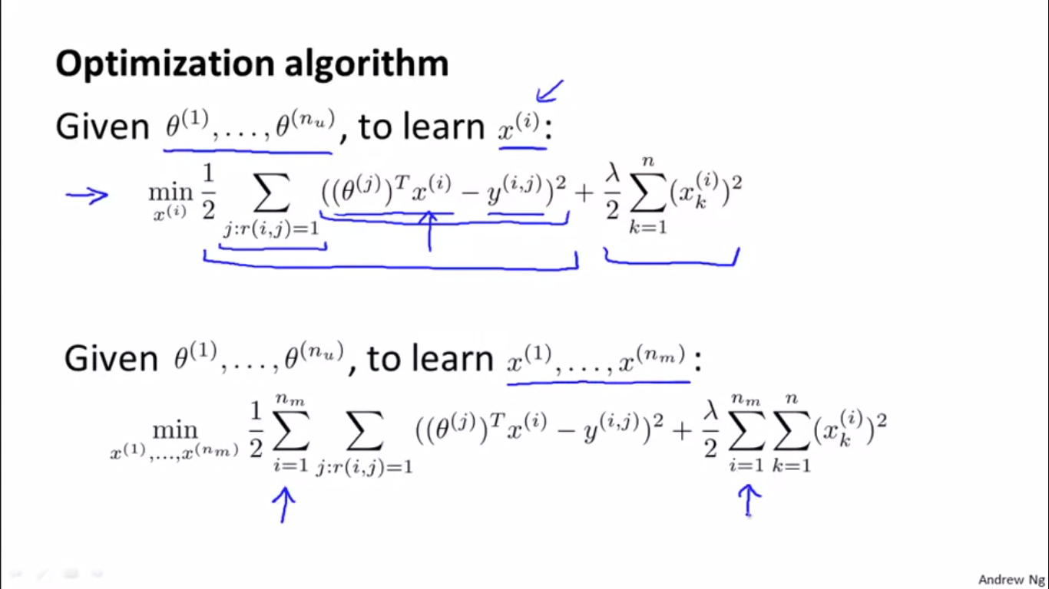 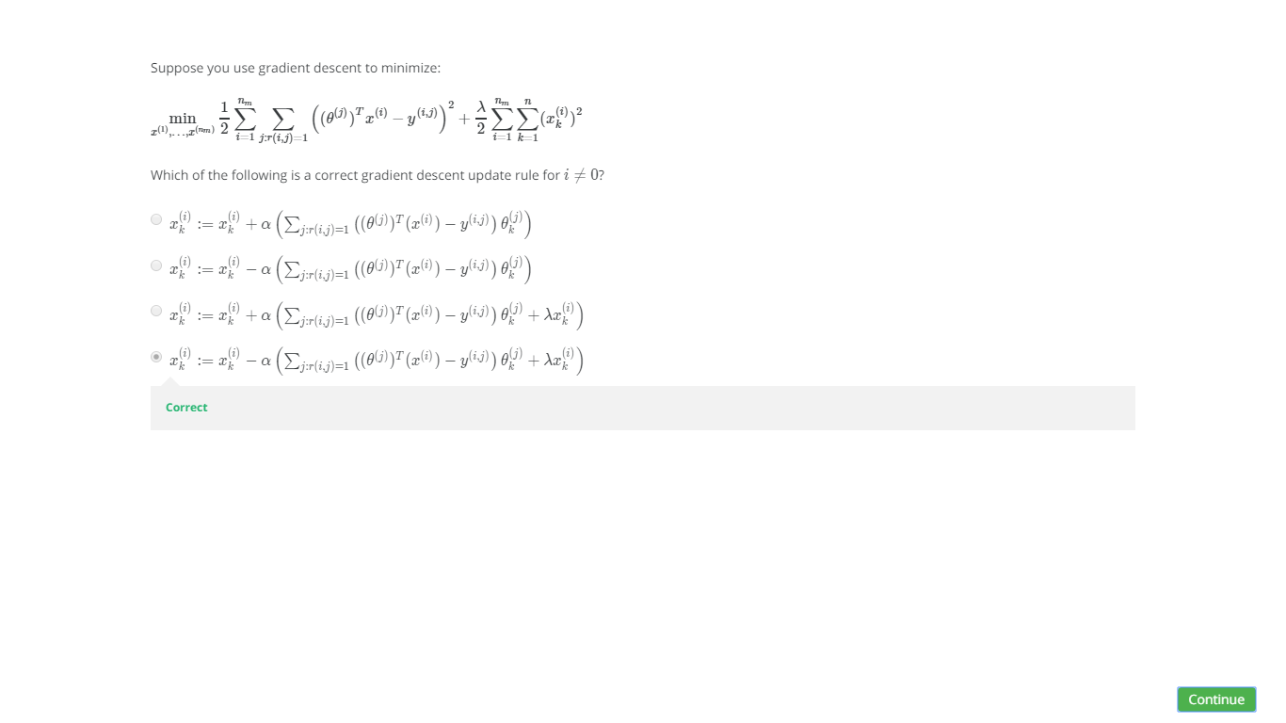

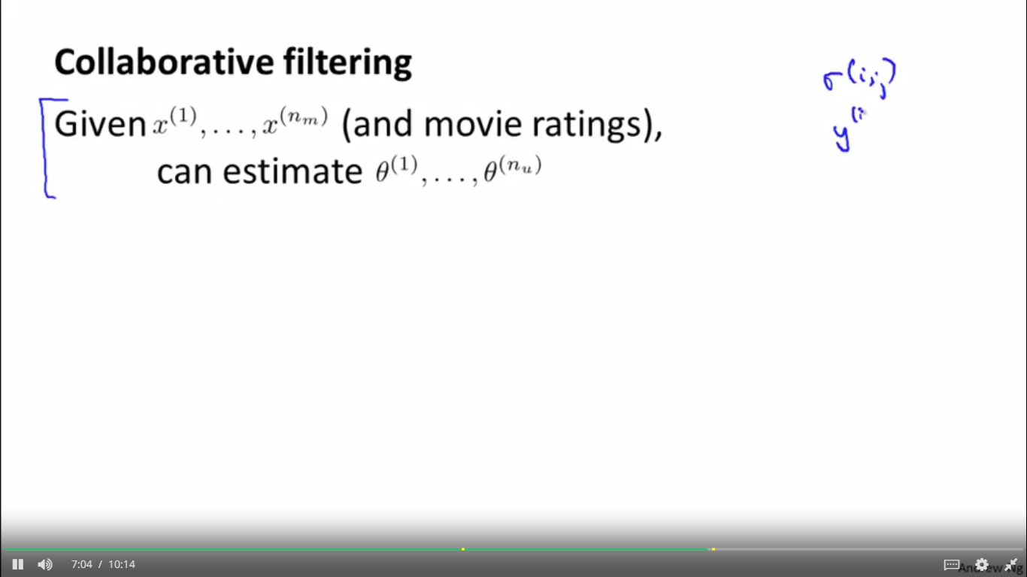 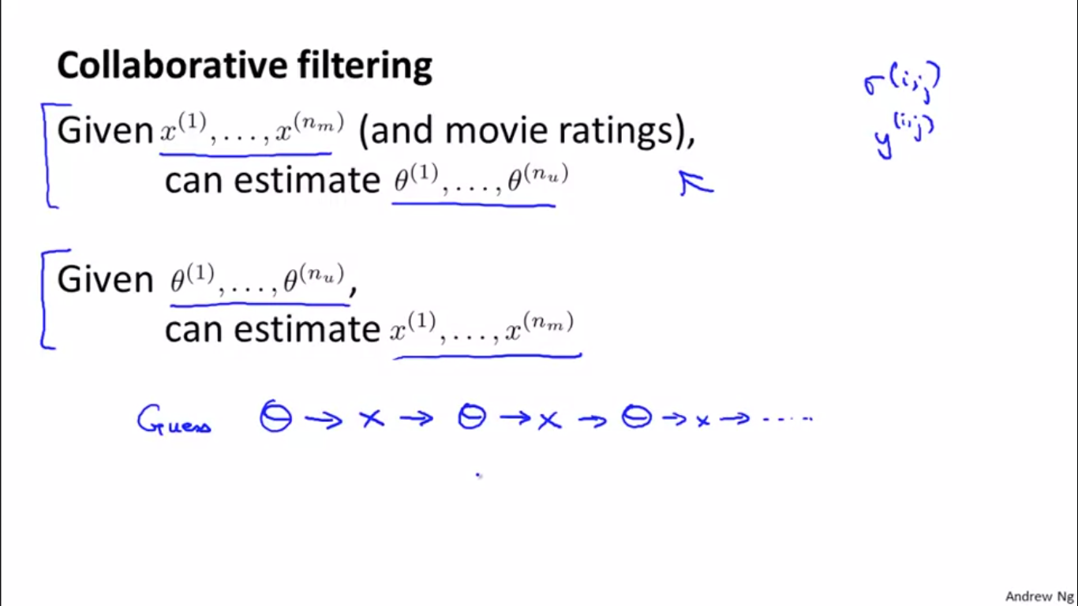 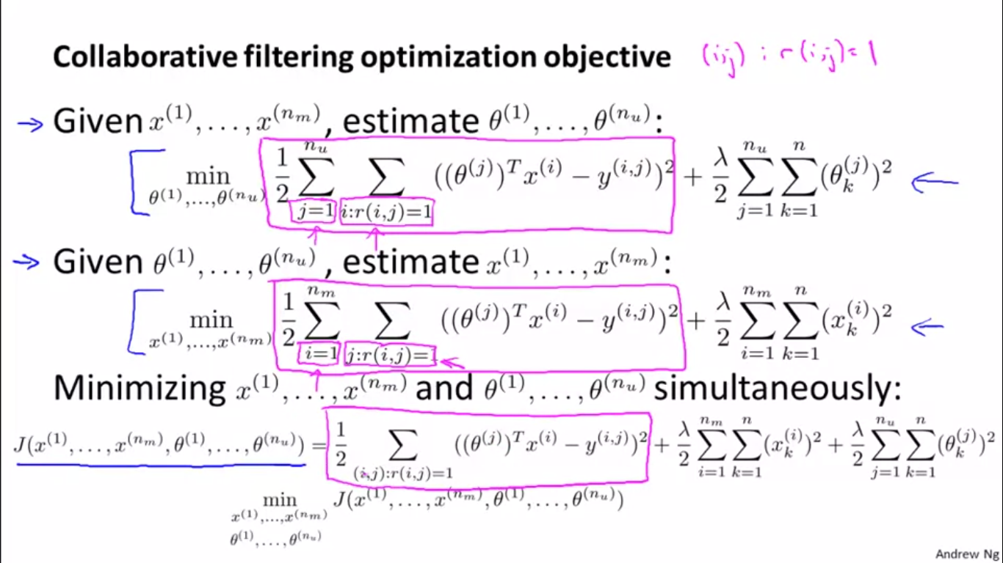 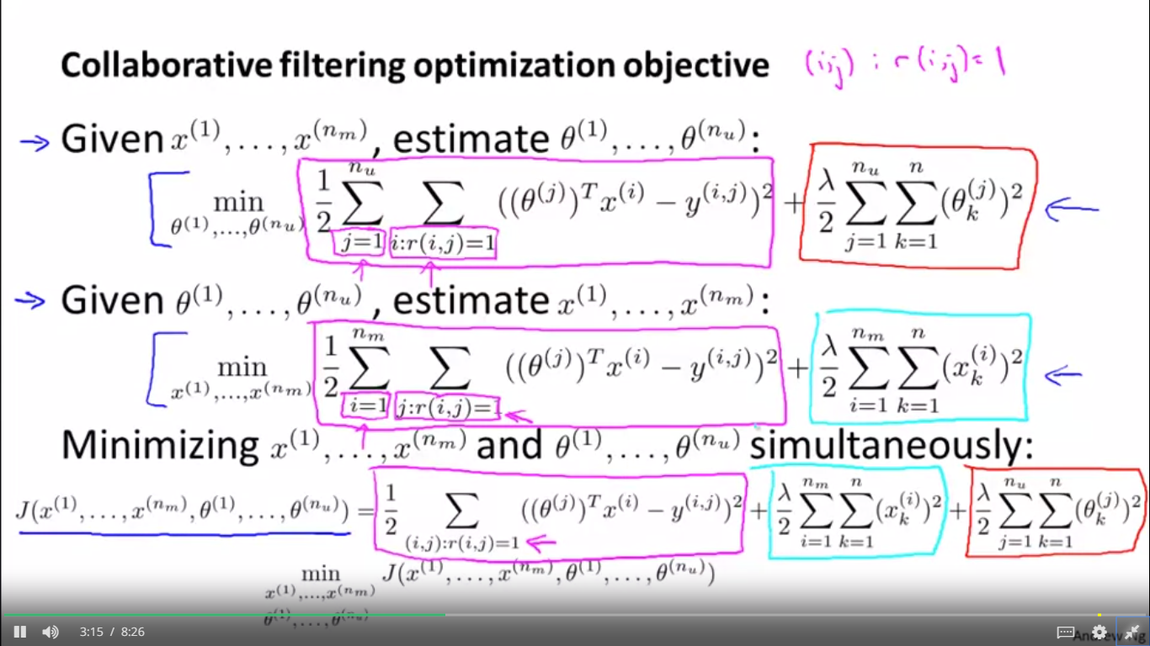 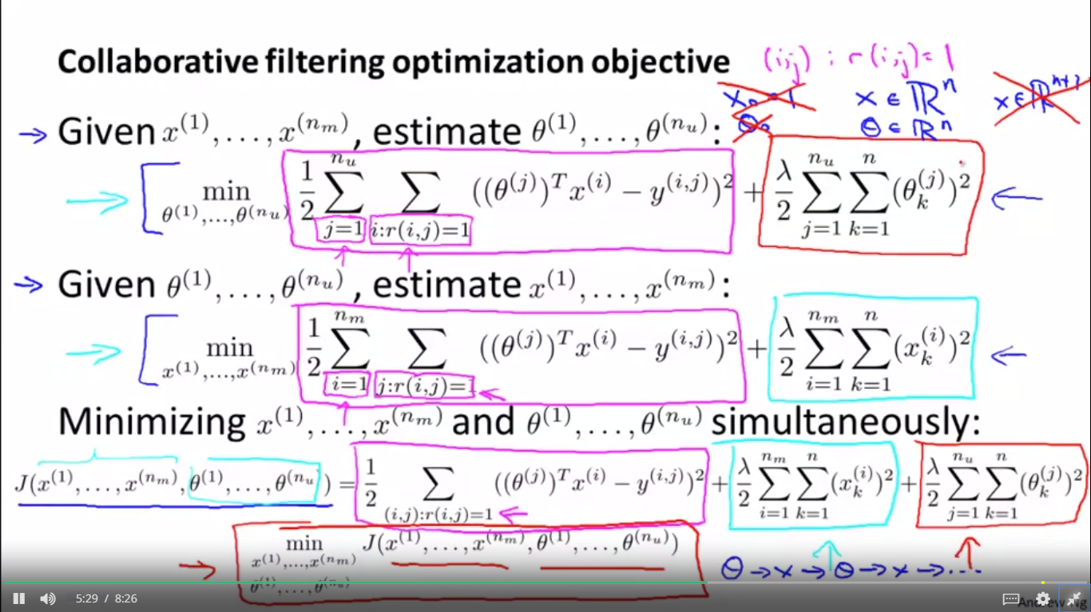 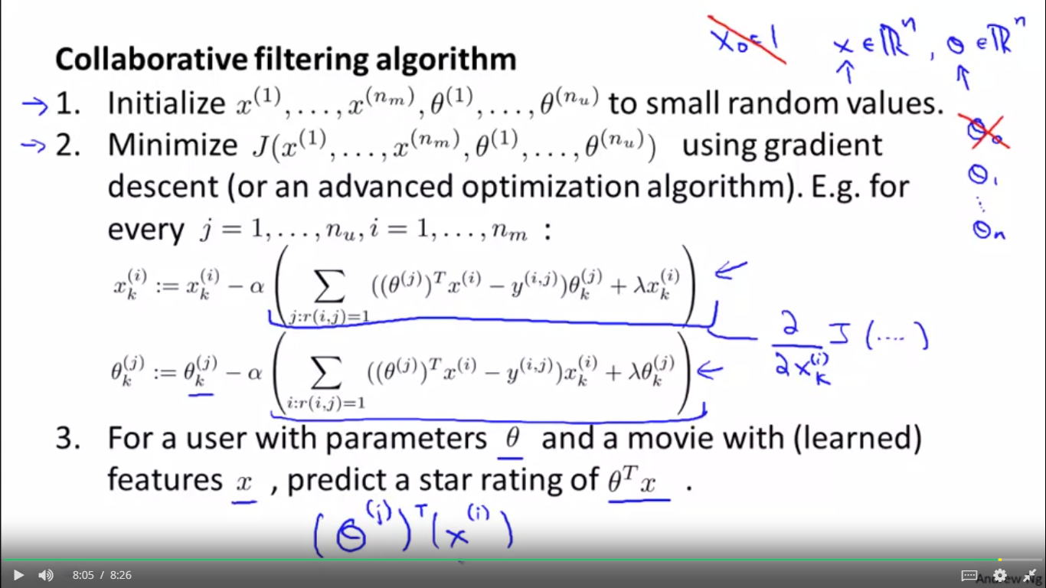

LOW RANK MATRIX FACTIRIZATION

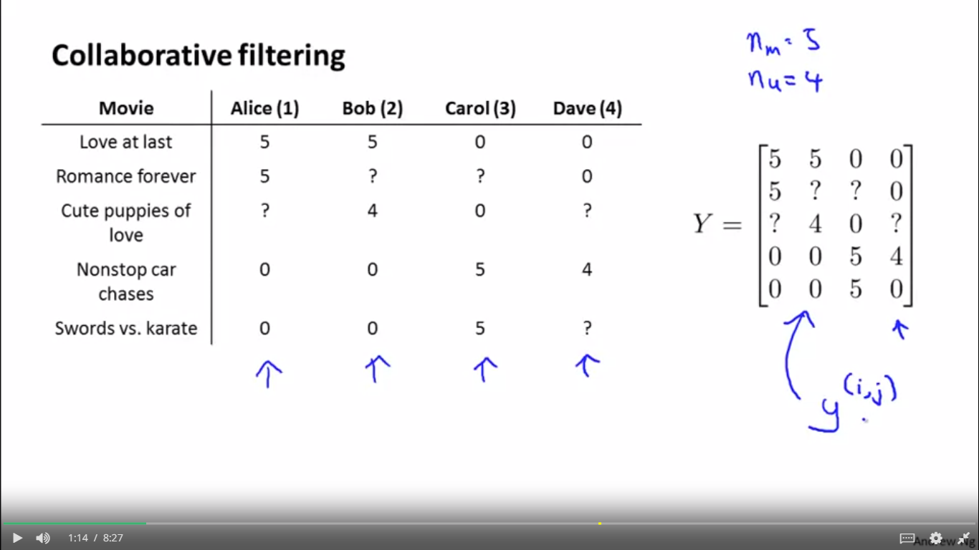 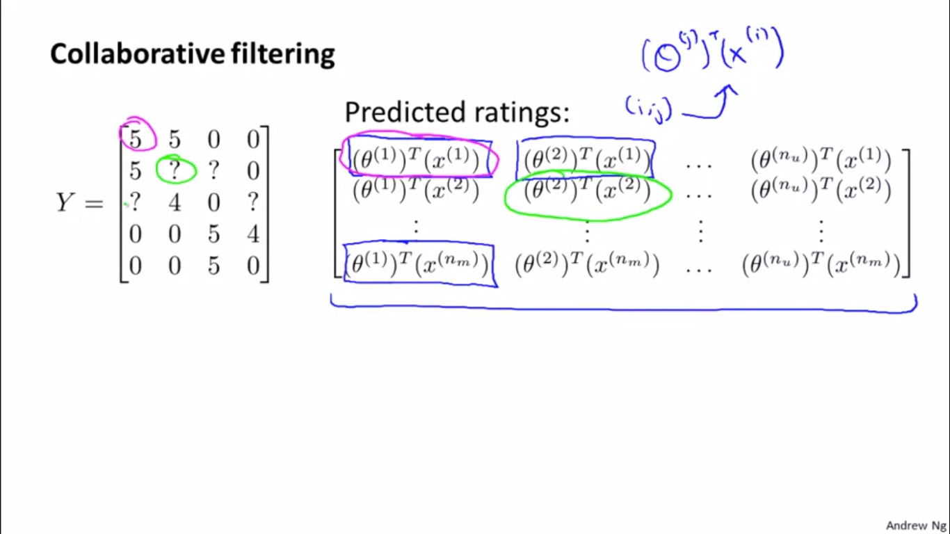 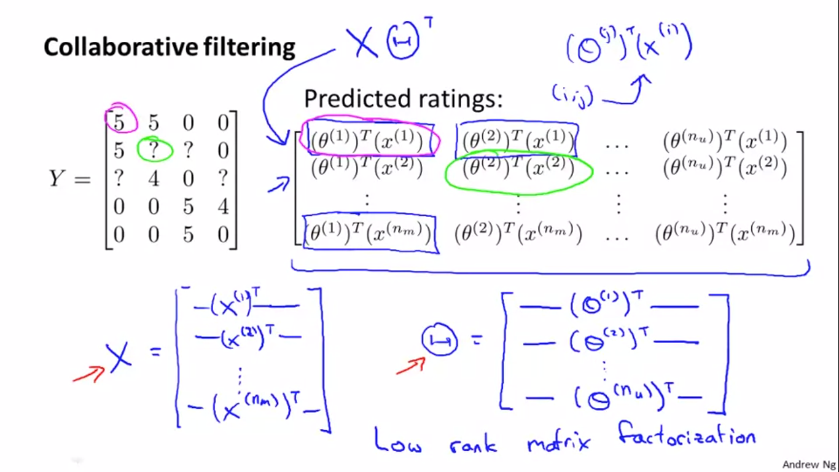 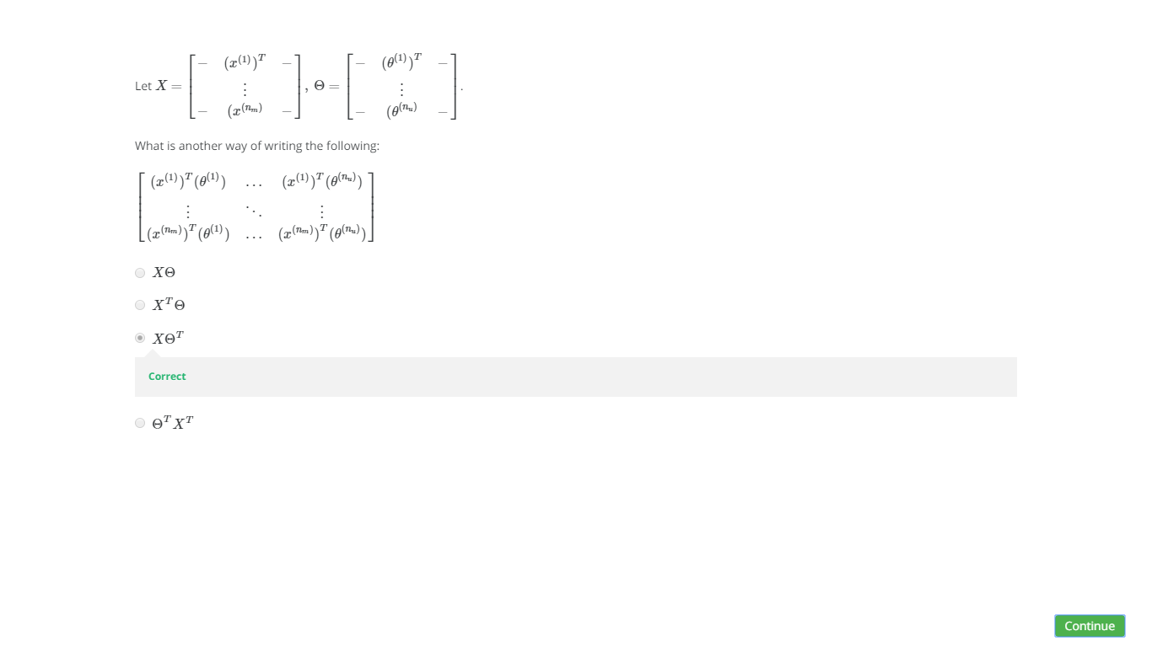 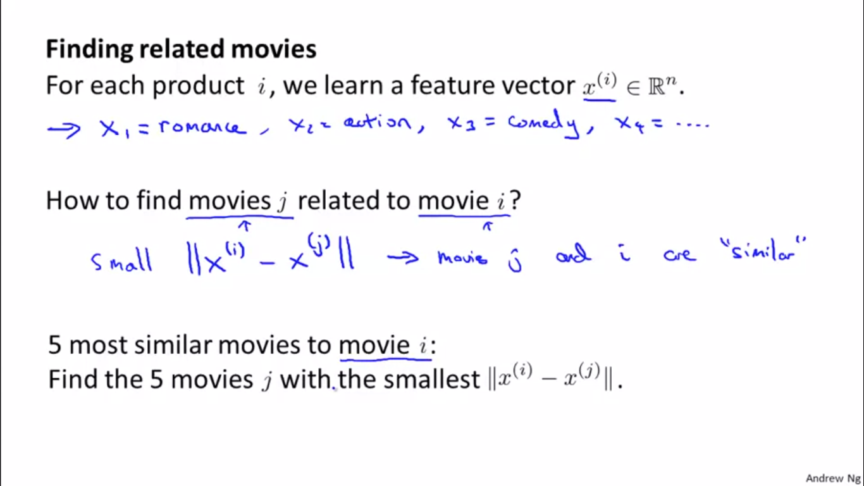

 now that you have learned these feature vectors, this gives us a very convenient way to

measure how similar two movies are. In particular, movie i has a feature vector xi and so if you can find a different movie, j, so that the distance between xi and xj is small,

7:33

then this is a pretty strong indication that, you know, movies j and i are somehow similar. At least in the sense that some of them likes movie i, maybe more likely to like movie j as well. So, just to recap, if your user is looking at some movie i and if you want to find the 5 most similar movies to that movie in order to recommend 5 new movies to them, what you do is find the five movies j, with the smallest distance between the features between these different movies. And this could give you a few different movies to recommend to your user. So with that, hopefully, you

now know how to use a vectorized implementation to compute all the predicted ratings of all the users and all the movies, and also how to do things like use learned features to find what might be movies and what might be products that aren't related to each other.